

| **IS3106 Group Project Written Report** | | **Group Leader:** | Thian Jiawen | **Matric**:  A0221875B |
| --- | --- | --- | --- | --- |
| **Project Group:** | GP13 | **Member 1:** | Jordan Wong Wei Bin | **Matric**: A0217188X |
| *“The world is a book and those who do not travel read only one page.” ~ Saint Augustine* | | **Member 2:** | Ryo Armando Wijaya | **Matric**: A0225877N |
| **Member 3:** | Chan Ming Jun, Marcus | **Matric**: A0216465A |
| **Name of Idea:** | | Optimal Travel Plan (OTP) | | |

**Table of Contents**

**Idea and Value Proposition** **4**

**Business Content** **6**

Revenue Model 6

Market Opportunity 7

Competitive Environment and Advantage 8

Marketing and Advertising Strategies 10

**Technical Content** **14**

Business Use Cases 14

Logical Data Model 17

Jakarta EE Component Diagrams 18

SessionBean Dependencies 20

Resource Classes Dependencies 21

ManagedBeans Dependencies 22

**Prototype Description** **23**

User interface 1: Jakarta Server Faces (JSF) 23

Admin submodule 24

Create/View/View a list of/Update/Delete Country 25

Create/View/View a list of/Update/Delete Tag 26

Create/View/View a list of/Update/Disable Account 27

View/View a list of/Resolve Support Requests 28

Add comment to Support Requests 29

Create/View/View a list of/Disable Services 30

Business Interface submodule 31

View Ratings, Income and Services Charts 31

Create/View/Update/Delete Account details (contact info/address) 32

Create/View/View a list of/Update/Disable Service 33

View/View a list of Booking Details 34

View/View a list of/Reply to review 35

Generate Booking Report 35

Create/View/View a list of/Disable Service Rate 36

User interface 2: Ionic 38

Index Page 39

Register as Customer 40

Login 41

Side Menu 42

Home Page 43

My Account 44

My Travel Itineraries 45

Create Support Request 46

View All my Support Requests 47

View a support request’s details 48

Manage Payment 49

Adding New Payment Method 50

View a List of Services 51

View a Service’s Details 52

View Travel Itinerary Details (Before Login) 53

Generate a Travel Itinerary 54

View Booking Details in a Travel Itinerary 55

Making Payment for a Travel Itinerary 56

View FAQ page 57

**References** **58**

**Appendix** **61**

# 

# 

# Idea and Value Proposition

Optimal Travel Plan (OTP) is an online travel itinerary planner which aims to capitalise on global tourism recovery by providing travellers with tailored suggestions for travel experiences. With a single click, holiday-makers receive a personalised travel itinerary for their holiday using recommendations from a pool of reputable services. From accommodation and food to tourist attractions, the customisable itinerary takes the trouble out of holiday planning, and makes the travel planning process fuss-free. The planner streamlines the information-hunting process, especially since the planner also considers cost, ratings, prevailing pandemic measures and other factors for the recommended attractions which resolve the troubles that travellers face as mentioned in Figure 1. To make travel planning even more seamless, travellers can directly book the recommended services from OTP’s website, making it a one-stop-shop for anybody who wants to plan their post-pandemic holidays easily.

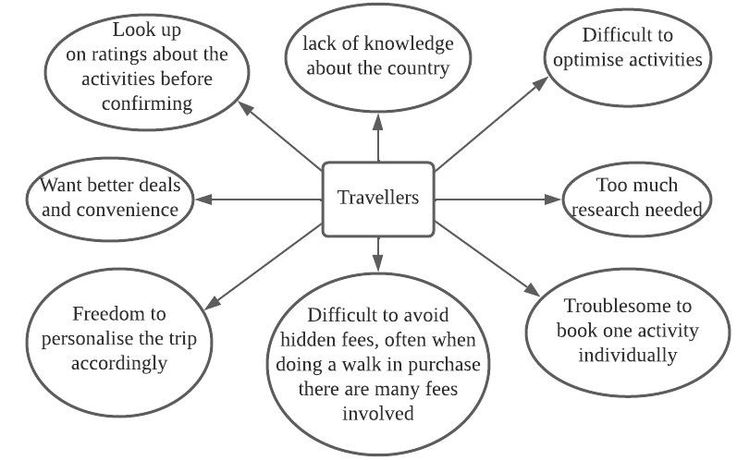

*Figure 1. Obstacles that travellers face when planning for holidays*

OTP supplements its personalised and customisable travel itinerary recommendations with profile customisation to stand out in a saturated market of B2C service-searching platforms. Users can tag their favourite services, allowing the system to prioritise them in the recommendations and build the itineraries around the user’s favourites. While many different platforms specialise in other services, OTP integrates multiple industries within the tourism sector, from entertainment and food and beverage (F&B) to accommodation (hotels and B&B). This helps to offer a uniform interface for customers to easily book and reserve their services for their travel plans, removing the complications and overhead of managing multiple accounts on different platforms.

OTP’s multi-industry integration also offers businesses the opportunity to extend their customer reach by signing up for an account with OTP and including their services in the recommendation pool. Customers who might be interested in other travel services and otherwise would not be reached by normal marketing channels would become aware of OTP’s partners due to the packaged nature of the recommended travel itineraries. Additionally, the personalised nature of OTP’s recommendations means that OTP can match travel service providers to their target audience through the suggested travel itineraries.

# Business Content

## Revenue Model

OTP’s current income would be largely based on commission fees and advertisement revenue. A basic commission fee would be collected from the businesses when each itinerary is confirmed and booked, as payment for the platform connecting users to the business. After travellers have made the payment, we would absorb the calculated commission before forwarding the transaction revenue to the businesses. However, food and beverage businesses will not be charged a commission since customers would only pay the businesses if they decide to follow the recommended itinerary and eat there. Hence, an alternate system is used where customer recommendations are dependent on the F&B company’s customer rating. Companies with low ratings in the travel guide will be recommended less frequently to travellers.

Businesses can opt to pay to advertise on the OTP webpages, creating another revenue stream. Advertisements would be displayed while creating and confirming the travel itinerary. This would further publicise the business and potentially influence customers to add the business’ services to their priority recommendations. As the advertisement market is worth **US$280 billion** in total with a growing revenue proportion coming from digital advertising (Adgate 2021), there is a market for businesses who would be interested in advertising their services online. Additionally, OTP can expand this enhancement model to customers in the future by providing the option to pay for the enhanced booking and recommendation features or even to customise the advertisements received. While this method converts OTP into a “freemium” usage model, it is viable as keeping the essential features free helps to attract customers while charging for premium features creates a sense of commitment for regular OTP users, encouraging them to keep using the platform.

## Market Opportunity

With increased global vaccination rates (Holder 2022) and the gradual reopening of international borders for tourism, the tourism industry is expected to gradually recover over the next few years as seen from how global international tourist arrivals have doubled in January 2022 compared to January 2021 (World Tourism Organisation 2022). Governments worldwide are also ramping up tourism recovery efforts, as seen by how the Singapore Tourism Board plans to continue partnerships with tourism-related businesses (Singapore Tourism Board 2022) and actively increase funding to the tourism sector by **S$500 million** in April 2022 (Lim 2022).

Given the potential for the tourism sector to regain its pre-pandemic vibrancy, travellers will be spoilt for choice regarding travel destinations, accommodation and experiences. However, existing pandemic measures like safe distancing and vaccination-dependent entry can cause headaches for travellers when they decide where to visit (BBC Travel 2022). Hence, OTP’s target audience is mostly leisure travellers who wish to plan a travel itinerary that fits their general budget and travelling style but does not have the time to research their destination in detail. This is especially applicable to travelling families as the adults presumably have their hands full without adding itinerary planning to the list. To some of these travellers, generic travel guides are not enough, and they want a tailored guide. OTP allows travellers to prepare for their trips any time, anywhere, while keeping multiple draft plans. Hence, there is an opening in the market for such a travel planning solution, mainly as OTP includes booking services for a one-stop travel planning experience.

OTP also presents an exciting publicity platform for travel-related companies. Businesses must make a free account with OTP to be included in the list of providers recommended to travellers. Key partners include major travel service providers, such as:

* Hotels of different price ranges, types, and locations to cater to the travellers' budget.
* Tourism businesses: Tourism businesses range from popular local restaurants to entertainment attractions.
* Transport: Transport partners can consist of car rental services or public transport cards. OTP will recommend a cost-effective travel option. Note that it will not show the specific route.
* Insurance providers: Insurance providers can offer different plans to travellers according to their coverage and travel needs.

## Competitive Environment and Advantage

Our direct competition includes other trip-planning websites such as Inspirock, which features itinerary planning and suggestions, commute and route details, and daily plans (Inspirock 2022). It provides the ability to dynamically customise a trip and navigate to booking websites to perform the actual booking. However, it does not help facilitate the confirmed booking, and customers will have to carry out the bookings individually. Indirect competitors such as Wanderlog also only provide the ability to search up and plan basic itineraries and offer the function to import existing travel plans without the capability for concrete booking or recommendation (Wanderlog 2022). Therefore, OTP aims to provide an all-in-one system that facilitates the potential to have a fully-booked itinerary from start to end, as shown in Figure 2.

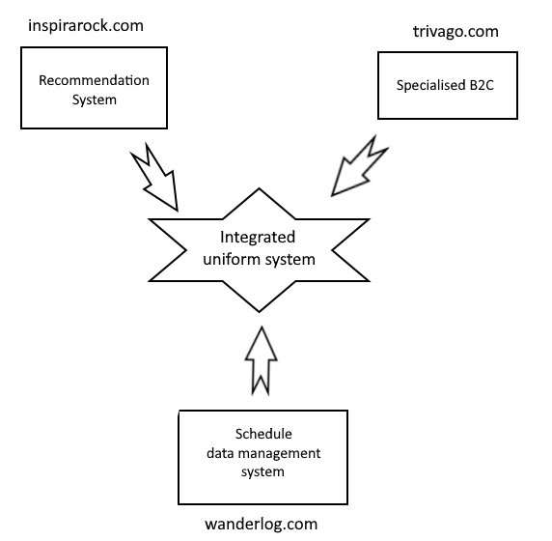

*Figure 2. Illustration of Optimal Travel Plan’s competitive environment.*

OTP is able to provide greater tailored personalisation by having a wide array of customisable customer preference selections that can be linked to a customer account and used to optimise a scheduled trip. It also provides enhanced flexibility to customise every aspect of a planned itinerary by individually editing or swapping itinerary items. In addition, OTP’s features are also available in a compact mobile application which is not offered in a number of our competitors’ solutions. While many of our competitors provide a certain degree of overlapping services, we aim to present our solution in a sleek and uncluttered manner designed to enhance usability.

## Marketing and Advertising Strategies

Consumers who would benefit from OTP’s features are most likely busy working adults who do not have enough time to do in-depth research on travel itineraries. If they have families, additional research is needed to determine which places are most suitable. OTP’s biggest selling point to consumers would be its all-in-one travel planning and booking system. Hence, consumer marketing strategies should emphasise the convenience that OTP brings to travellers who simply want a relaxing and fuss-free getaway from their busy lives.

To determine the best platform to advertise OTP, understanding its target audience. To have enough disposable income to be able to travel for leisure, many of OTP’s consumers will be from highly developed countries like Singapore and the United States. Such countries generally have good infrastructure which allows for high internet access rates. For example, Singapore has an internet adoption rate of 92% (We are Social 2022), while the United States has an internet access rate of 79.9%, with access rates higher in urban areas (OECD 2022). With easy access to the internet, Singaporeans are highly accustomed to using it as a source of information, news and social interaction. Therefore, employing digital marketing would be effective in reaching much of OTP’s target audience.

To further optimise the digital marketing strategy, OTP should evaluate the potential of different online platforms. Regarding websites accessed, the Google search engine is one of the most popular websites in Singapore, receiving more than half of the total website traffic from mobile devices in February 2022 (Semrush 2022). As such, advertising on Google has a high possibility of reaching out to OTP’s target audience of travellers who might be researching their holiday plans using the search engine. Google advertisements work by setting up a target demographic and providing a budget to Google Ads, introducing the advertised search result at the top of relevant search pages (Google Ads 2022). As shown in Figure 3, boosted search results are prominently displayed as the first result related to the original search desired. In OTP’s case, the OTP website link would be displayed on the top of search results for terms like “travel planner”, “things to do while travelling”, and “travel itinerary”, which helps to raise awareness of OTP and possibly increase website traffic to the site as curious users decide to visit it to try planning their travel itineraries. Google Ads also provides options for embedded advertisements into travel websites and video advertisements, hence providing various possible future marketing opportunities to raise consumer awareness about OTP. However, Google Search marketing is still the most optimal strategy for OTP, as increased website traffic is helpful for Google’s search engine algorithm to rank it as a more promoted search result and attract casual searchers who do not look past the first few search results (Google 2022). Additionally, the flexible budget means that the initial risk of advertising is low and feasible for fresh concepts like OTP that might not have a lot of starting capital. If the initial advertising campaign is successful, OTP can run future advertisements with a higher budget.

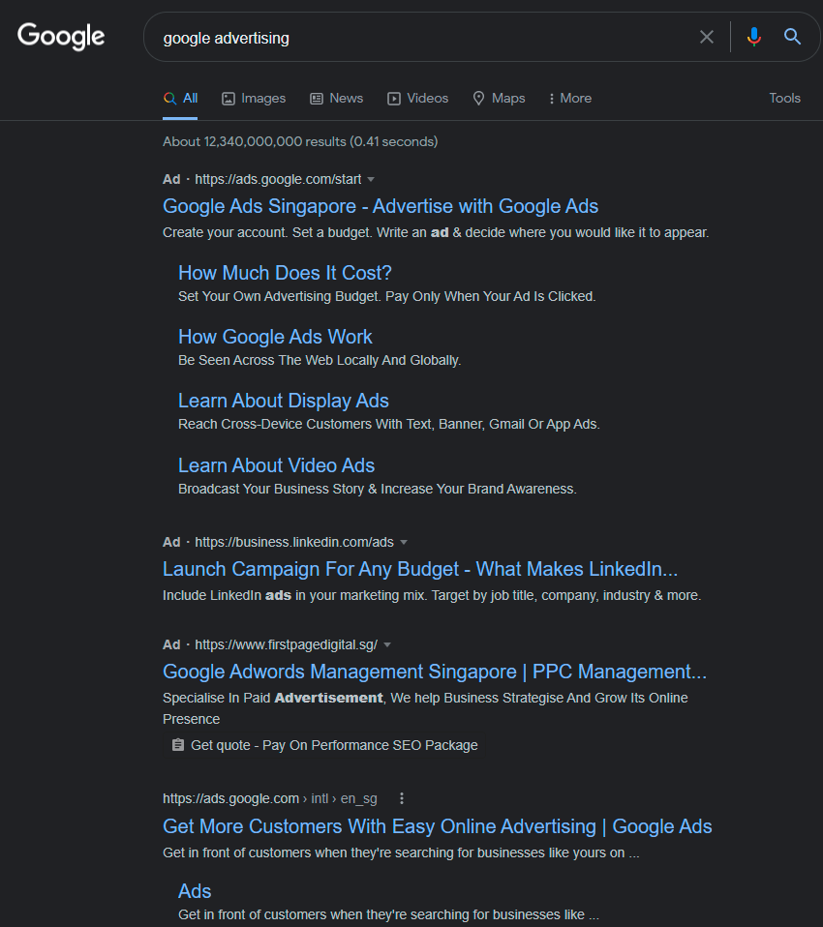

*Figure 3. Google Search Advertisement. Note the top results marked with “Ad”.*

Other than Google, the rest of Singapore’s website traffic is largely shared between local news outlets like The Straits Times and CNA and social media sites like YouTube, Facebook, Reddit, and Instagram (Semrush 2022). Social media sites receiving a lot of traffic is unsurprising, considering the high social media usage rate in much of the developed world. For example, 89.5% of Singaporeans (We are Social 2022) and 72% of American adults (Pew Research Center 2021) are active social media users. During the pandemic, the amount of time Singaporeans have spent consuming media on the internet has increased by 7.8%. Notably, Singaporeans spent 27.2% more time listening to music streaming services, 55.6% more time listening to podcasts, 10.2% more time on social media and 34% more time-consuming news online than in 2021 (We are Social 2022). Hence, in terms of digital media exposure, OTP’s marketing is more likely to succeed on music streaming services and social media. Even though more people are consuming news online, the serious nature of most news outlets means that leisure topics like travel planning would not find much success outside of the lifestyle pages.

Social media advertising is very similar to Google Ads’ model. Businesses pick a platform, target demographic and budget before relying on the sites’ respective algorithms to recommend the advertisement to relevant consumers by pairing the advertisement with similar content (Instagram 2022). By showing up together with related posts of attractive travel-related content, social media users interested in travel would be more inclined to check out OTP’s services. Like Google advertisements, social media advertising’s flexible budget means a lower risk with potentially high rewards in the future. However, unlike search engine advertising, OTP must do additional work to establish a significant social media presence for itself to increase consumer trust and be more in tune with consumer interests.

Search engine and social media advertising have the benefits of being relatively low-cost and effective by influencing consumers' recommendations. Still, they have significant drawbacks in terms of how much control OTP has over the marketing strategy details due to high reliance on these sites’ recommendation algorithms. Taking inspiration from how these methods entice consumers by bundling the advertisement with content they are interested in, OTP can use industry collaborations to attract more consumers. This method has an additional advantage of involving businesses that might want to include their services into OTP’s recommendation pool, eventually earning the OTP business its commission and internal advertising revenue. To onboard companies with OTP, OTP can consider a promotional rate for the commission fee, which applies to the first few businesses that sign up for an OTP account. Afterwards, these businesses could introduce small promotions for customers who sign up for their services through OTP. This is a win-win situation for OTP and the participating service providers, as OTP gains more active users on both the consumer and commercial sides. In contrast, the service providers build a more substantial presence on the OTP platform and receive more recommended customers due to their higher rating on the site. To increase outreach to travel service providers, OTP can consider promoting demos of the website to such businesses, emphasising its simple and uncomplicated user interface, data management, and advertising services.

# Technical Content

## Business Use Cases

(Use cases that support multi-attribute filtering are marked accordingly in the diagram as confirmed in Microsoft Teams: “You can just indicate the main use case then use an annotation note to put a brief remark that the use case support filtering”)

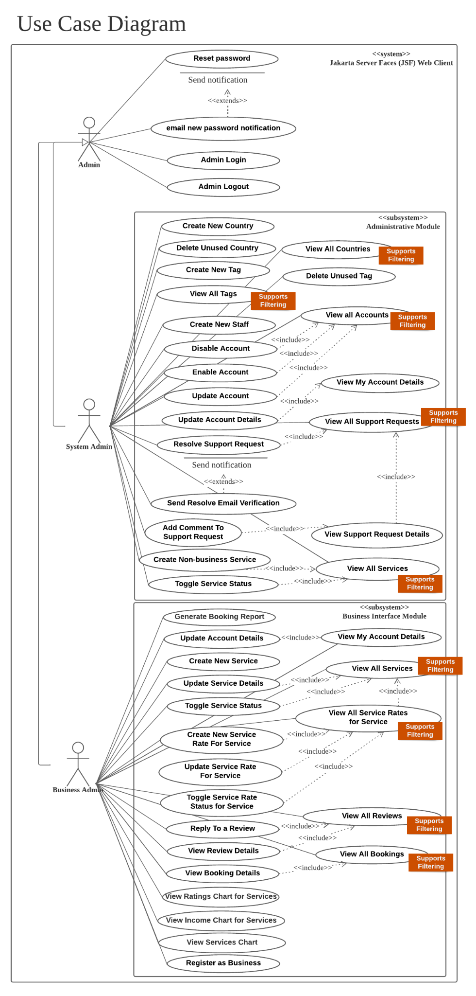

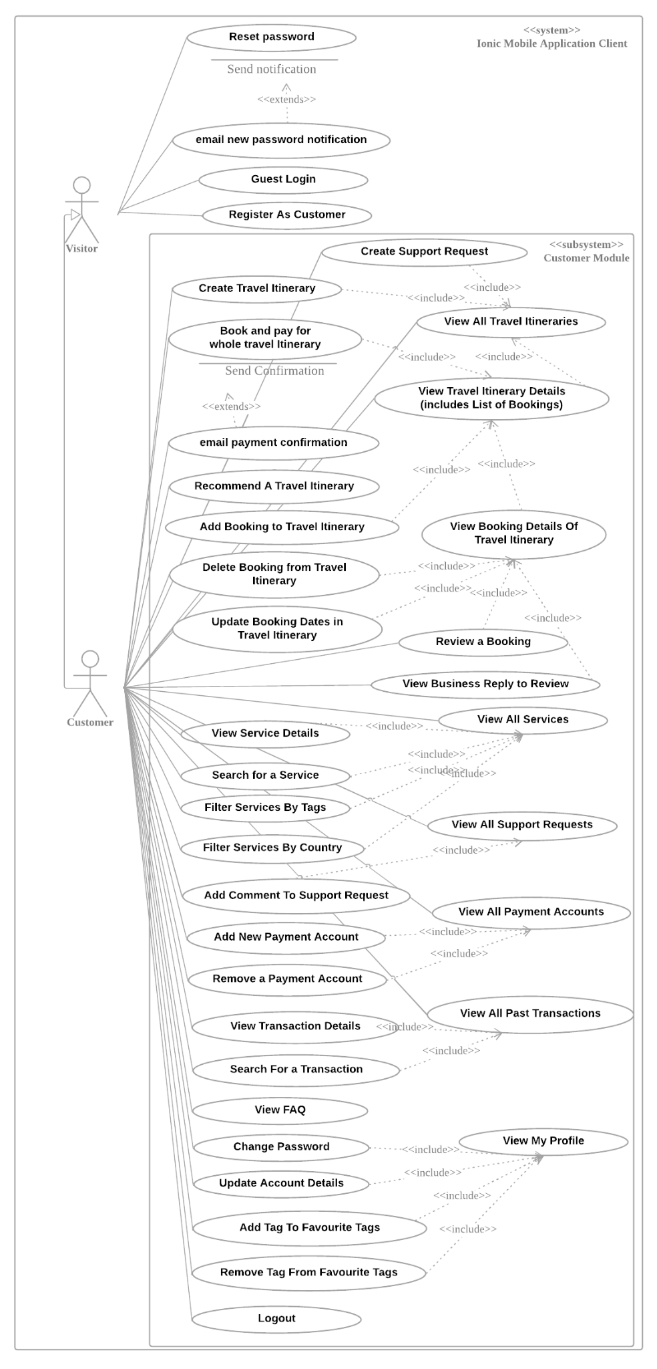

## Logical Data Model

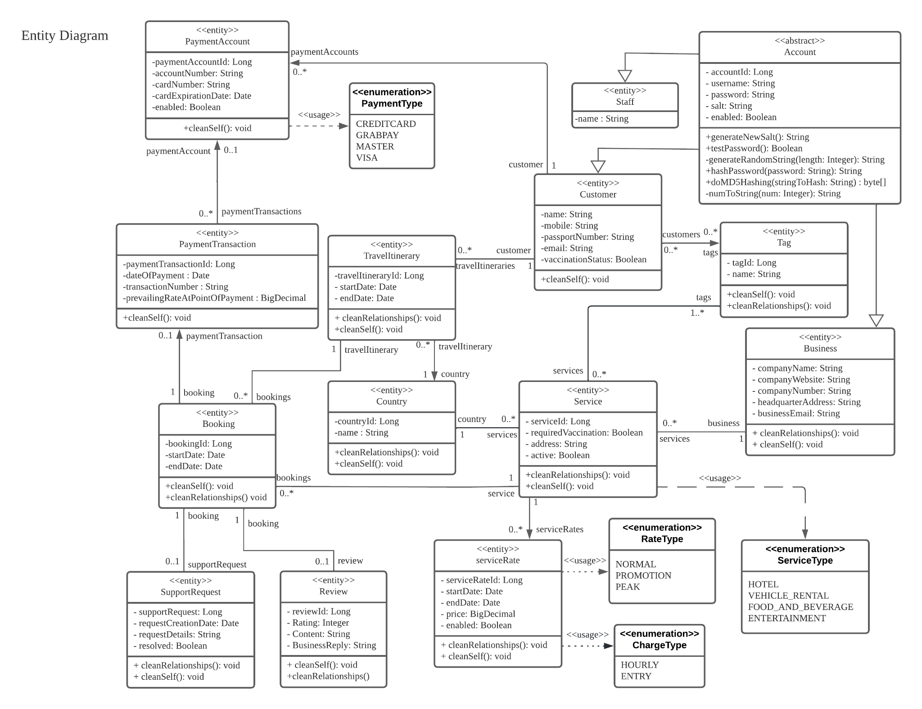

(See Appendix for clearer diagrams)

## Jakarta EE Component Diagrams

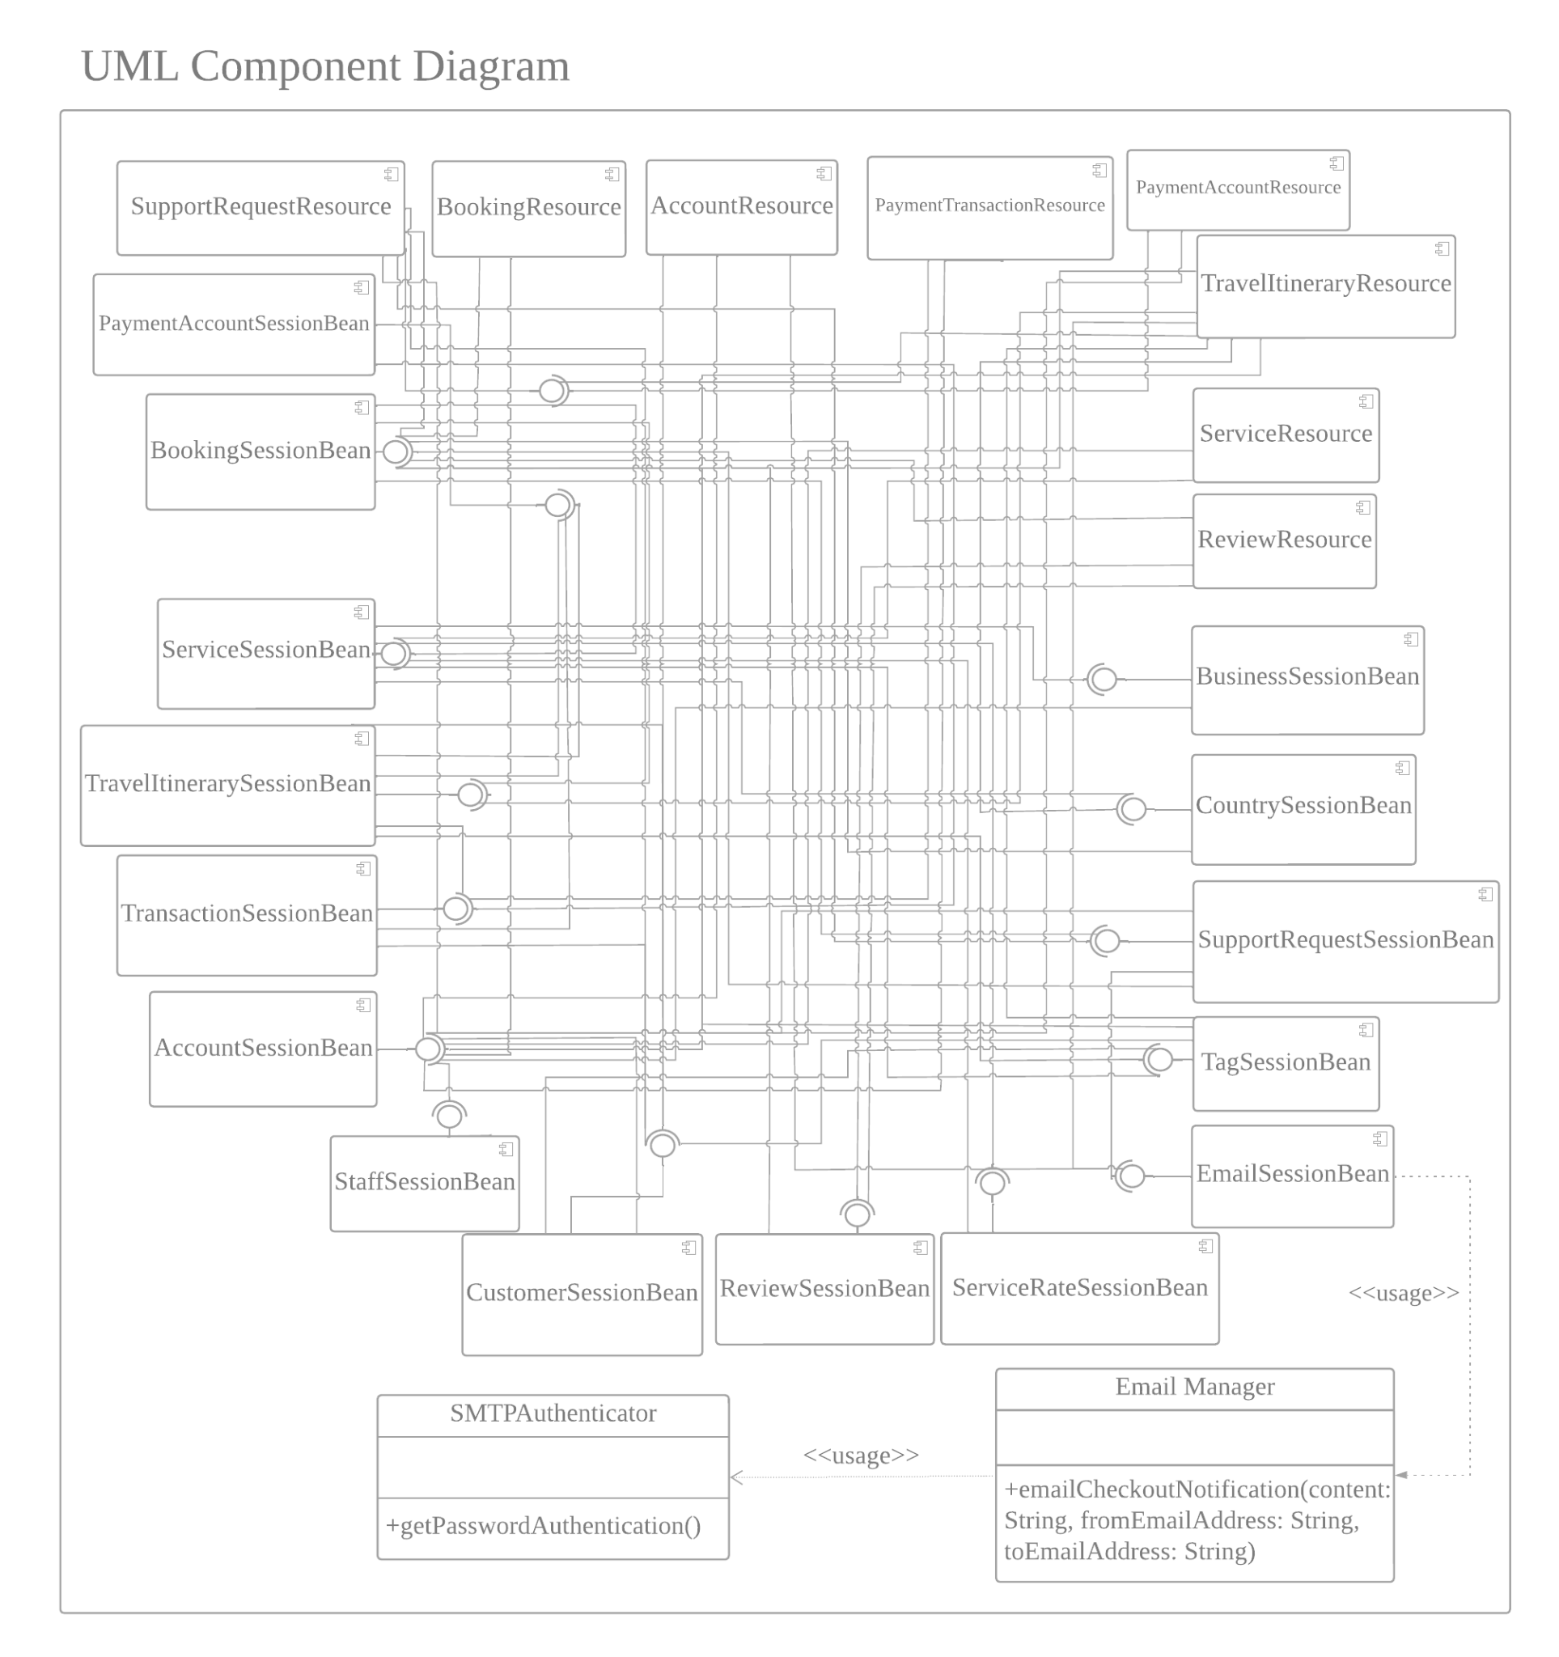

*Figure 4: UML Diagram*

Disclaimer: For the diagram above, all interfaces for the components have the name of its own component name with “Local” appended. For example, the above “CustomerSessionBean” has the interface name “CustomerSessionBeanLocal”. This was omitted from the diagram for improved readability.

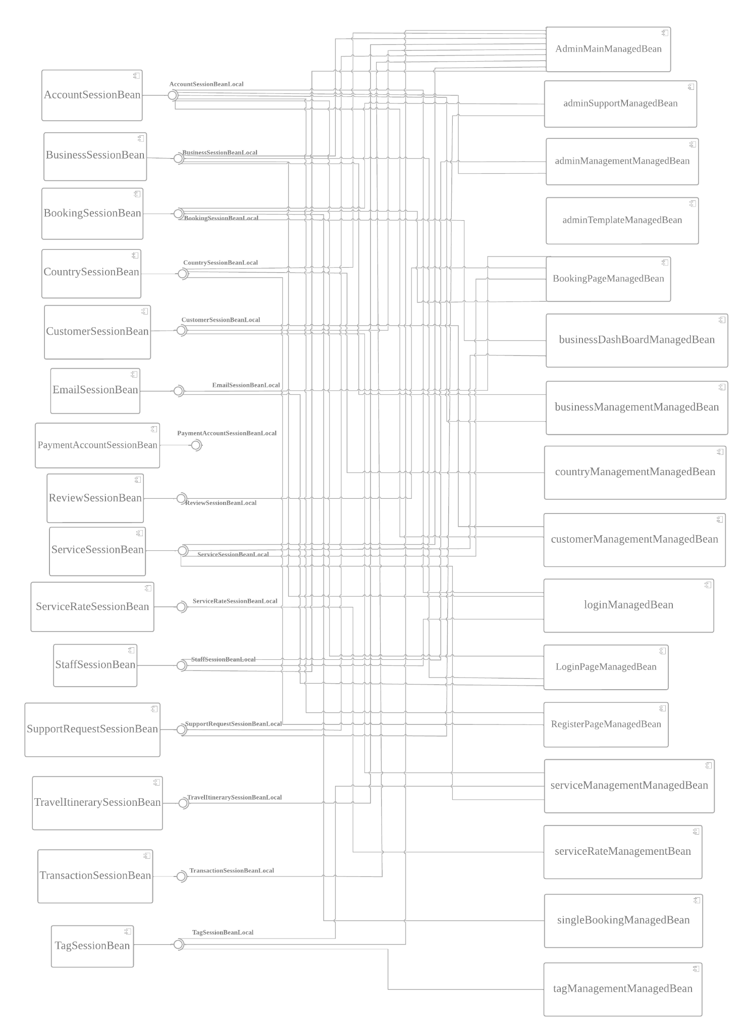

*Figure 5: UML Component Diagram*

As the above component diagrams may be difficult to read due to the complex nature of our application, below is a list of each component and its dependencies.

### SessionBean Dependencies

| **Component** | **Dependencies** |
| --- | --- |
| CountrySessionBean | BookingSessionBeanLocal |
| ReviewSessionBean | BookingSessionBeanLocal |
| SupportRequestSessionBean | AccountSessionBeanLocal  EmailSessionBeanLocal  BookingSessionBeanLocal |
| BusinessSessionBean | AccountSessionBeanLocal |
| StaffSessionBean | AccountSessionBeanLocal |
| ServiceRateSessionBean | ServiceSessionBeanLocal |
| AccountSessionBean | NIL |
| TransactionSessionBean | CustomerSessionBeanLocal  PaymentAccountSessionBeanLocal  BookingSessionBeanLocal |
| BookingSessionBean | SupportRequestSessionBeanLocal  TravelItinerarySessionBeanLocal  ServiceSessionBeanLocal |
| TravelItinerarySessionBean | TransactionSessionBeanLocal  PaymentAccountSessionBeanLocal  CustomerSessionBeanLocal  TagSessionBeanLocal  ServiceSessionBeanLocal  BookingSessionBeanLocal |
| EmailSessionBean | NIL |
| CustomerSessionBean | TagSessionBeanLocal  AccountSessionBeanLocal |
| TagSessionBean | BookingSessionBeanLocal  CustomerSessionBeanLocal |
| PaymentAccountSessionBean | TransactionSessionBeanLocal |
| ServiceSessionBean | BusinessSessionBeanLocal  CountrySessionBeanLocal  ServiceRateSessionBeanLocal  TagSessionBeanLocal |

### Resource Classes Dependencies

| **Component** | **Dependencies** |
| --- | --- |
| AccountResource | EmailSessionBeanLocal CustomerSessionBeanLocal  AccountSessionBeanLocal |
| PaymentAccountResource | AccountSessionBeanLocal  PaymentAccountSessionBeanLocal |
| ServiceResource | AccountSessionBeanLocal  ServiceSessionBeanLocal |
| PaymentTransactionResource | AccountSessionBeanLocal  TransactionSessionBeanLocal |
| SupportRequestResource | SupportRequestSessionBeanLocal  AccountSessionBeanLocal  CustomerSessionBeanLocal  BookingSessionBeanLocal |
| TravelItineraryResource | TravelItinerarySessionBeanLocal  PaymentAccountSessionBeanLocal  AccountSessionBeanLocal  TagSessionBeanLocal  ServiceSessionBeanLocal  BookingSessionBeanLocal  EmailSessionBeanLocal |
| ReviewResource | BookingSessionBeanLocal  ReviewSessionBeanLocal |
| BookingResource | AccountSessionBeanLocal  BookingSessionBeanLocal |

### 

### ManagedBeans Dependencies

| **Component** | **Dependencies** |
| --- | --- |
| AdminMainManagedBean | SupportRequestSessionBeanLocal  TagSessionBeanLocal  CountrySessionBeanLocal  ServiceSessionBeanLocal  TravelItinerarySessionBeanLocal  TransactionSessionBeanLocal  StaffSessionBeanLocal  BusinessSessionBeanLocal  CustomerSessionBeanLocal |
| BookingPageManagedBean | EmailSessionBeanLocal  ServiceSessionBeanLocal  ReviewSessionBeanLocal  BookingSessionBeanLocal |
| LoginPageManagedBean | EmailSessionBeanLocal  BusinessSessionBeanLocal  AccountSessionBeanLocal |
| RegisterPageManagedBean | CountrySessionBeanLocal  AccountSessionBeanLocal |
| adminManagementManagedBean | StaffSessionBeanLocal  AccountSessionBeanLocal |
| adminSupportManagedBean | SupportRequestSessionBeanLocal  BookingSessionBeanLocal |
| adminTemplateManagedBean | NIL |
| businessDashBoardManagedBean | BookingSessionBeanLocal  ServiceSessionBeanLocal |
| businessManagementManagedBean | BusinessSessionBeanLocal  AccountSessionBeanLocal |
| countryManagementManagedBean | CountrySessionBeanLocal |
| customerManagementManagedBean | CustomerSessionBeanLocal  AccountSessionBeanLocal |
| loginManagedBean | AccountSessionBeanLocal  BusinessSessionBeanLocal  StaffSessionBeanLocal |
| serviceManagementManagedBean | CountrySessionBeanLocal  TagSessionBeanLocal  ServiceSessionBeanLocal |
| serviceRateManagementManagedBean | ServiceRateSessionBeanLocal |
| singleBookingManagedBean | BookingSessionBeanLocal |
| tagManagementManagedBean | TagSessionBeanLocal |

# Prototype Description

One set of prototype description write-up and sample screenshots for each of the front-end applications (at least two). Total of at least two sets.

## **User interface 1: Jakarta Server Faces (JSF)**

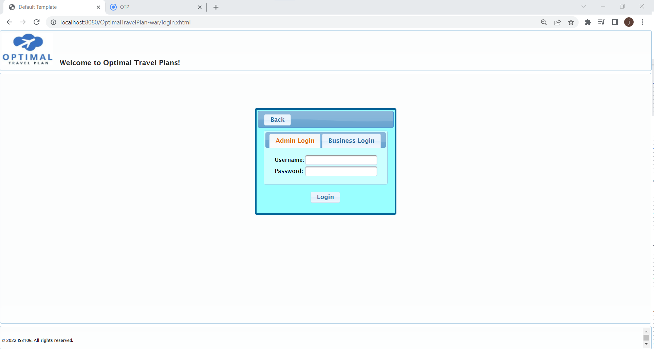  
*Figure 6: JSF Login page*

The JSF interface will be created for businesses to connect to our platform, providing crucial operations for setting up their business and managing bookings. It will also be used for administrative handling. The JSF interface consists of two submodules which fulfil the following use cases:

### **Admin submodule**

This submodule is meant to provide an interface for administrators to manage accounts, services, tags and countries and view a dashboard of statistics related to the business functions of the application. Admins can also partake in a chat based system to resolve support requests started by customers.

**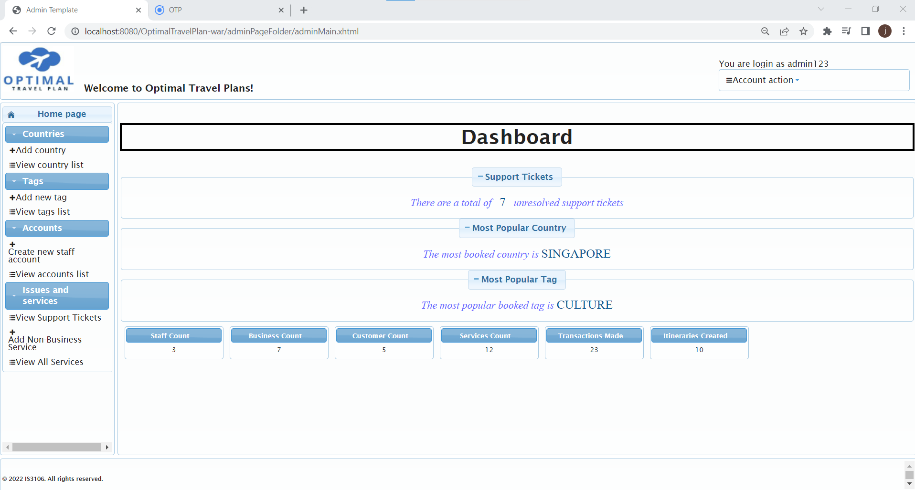***Figure 7: Admin Homepage*

Our admin dashboard provides a condensed view of new data, used for important processes, such as support tickets that are still unresolved, most popular tags and countries, and aggregate data of the database. This dashboard will allow admins to get to work quickly, or for higher management staff to make business decisions for Optimal Travel Plan, for example which country to expand to, or what markets to focus on with respect to popularity among our clients.

#### Create/View/View a list of/Update/Delete Country

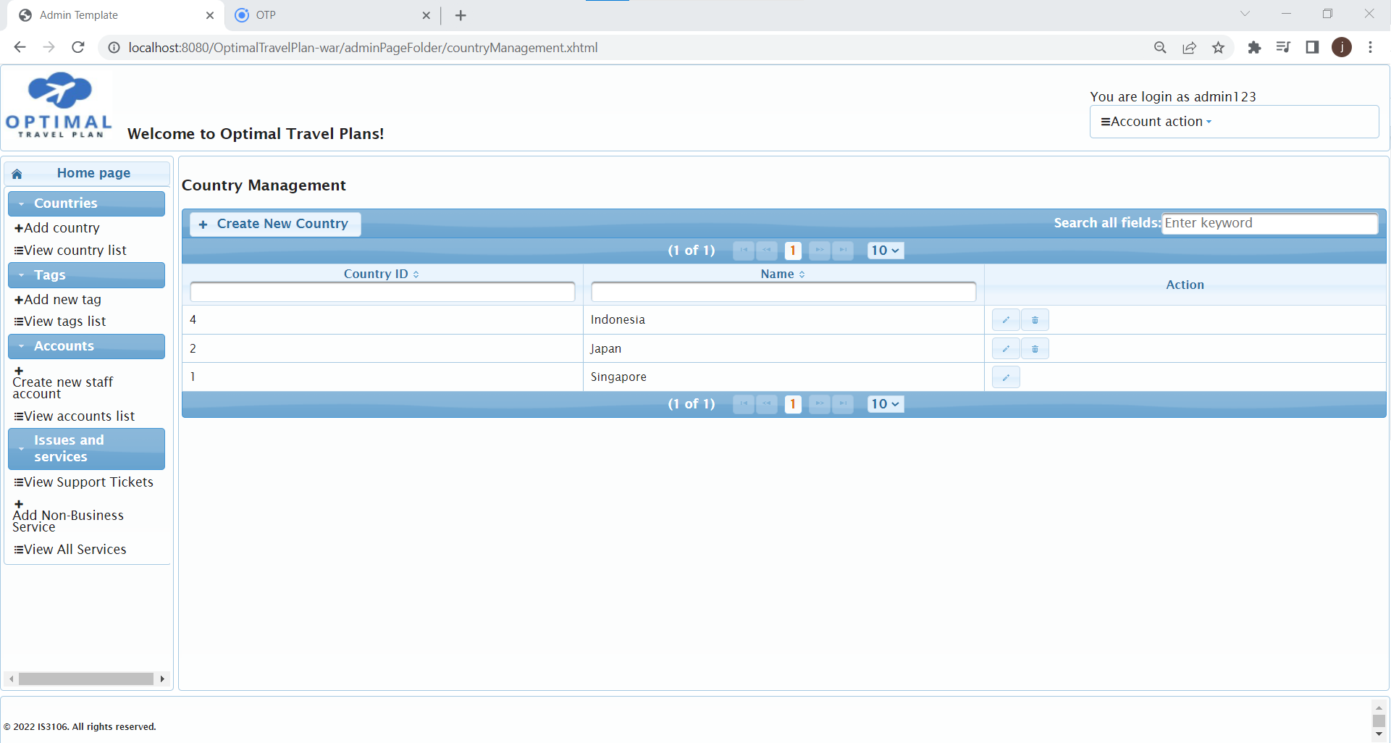

*Figure 8: Country Management*

The country management page allows the staff of Optimal Travel Plan to add, amend and remove countries available in our service. However, the deletion of the country would only be allowed if there are no services listed by businesses in the country. Only businesses from the listed countries would be able to sign up and list their services for bookings. Similarly the customer would only be able to generate travel itinerary from the available countries in the database.

#### Create/View/View a list of/Update/Delete Tag

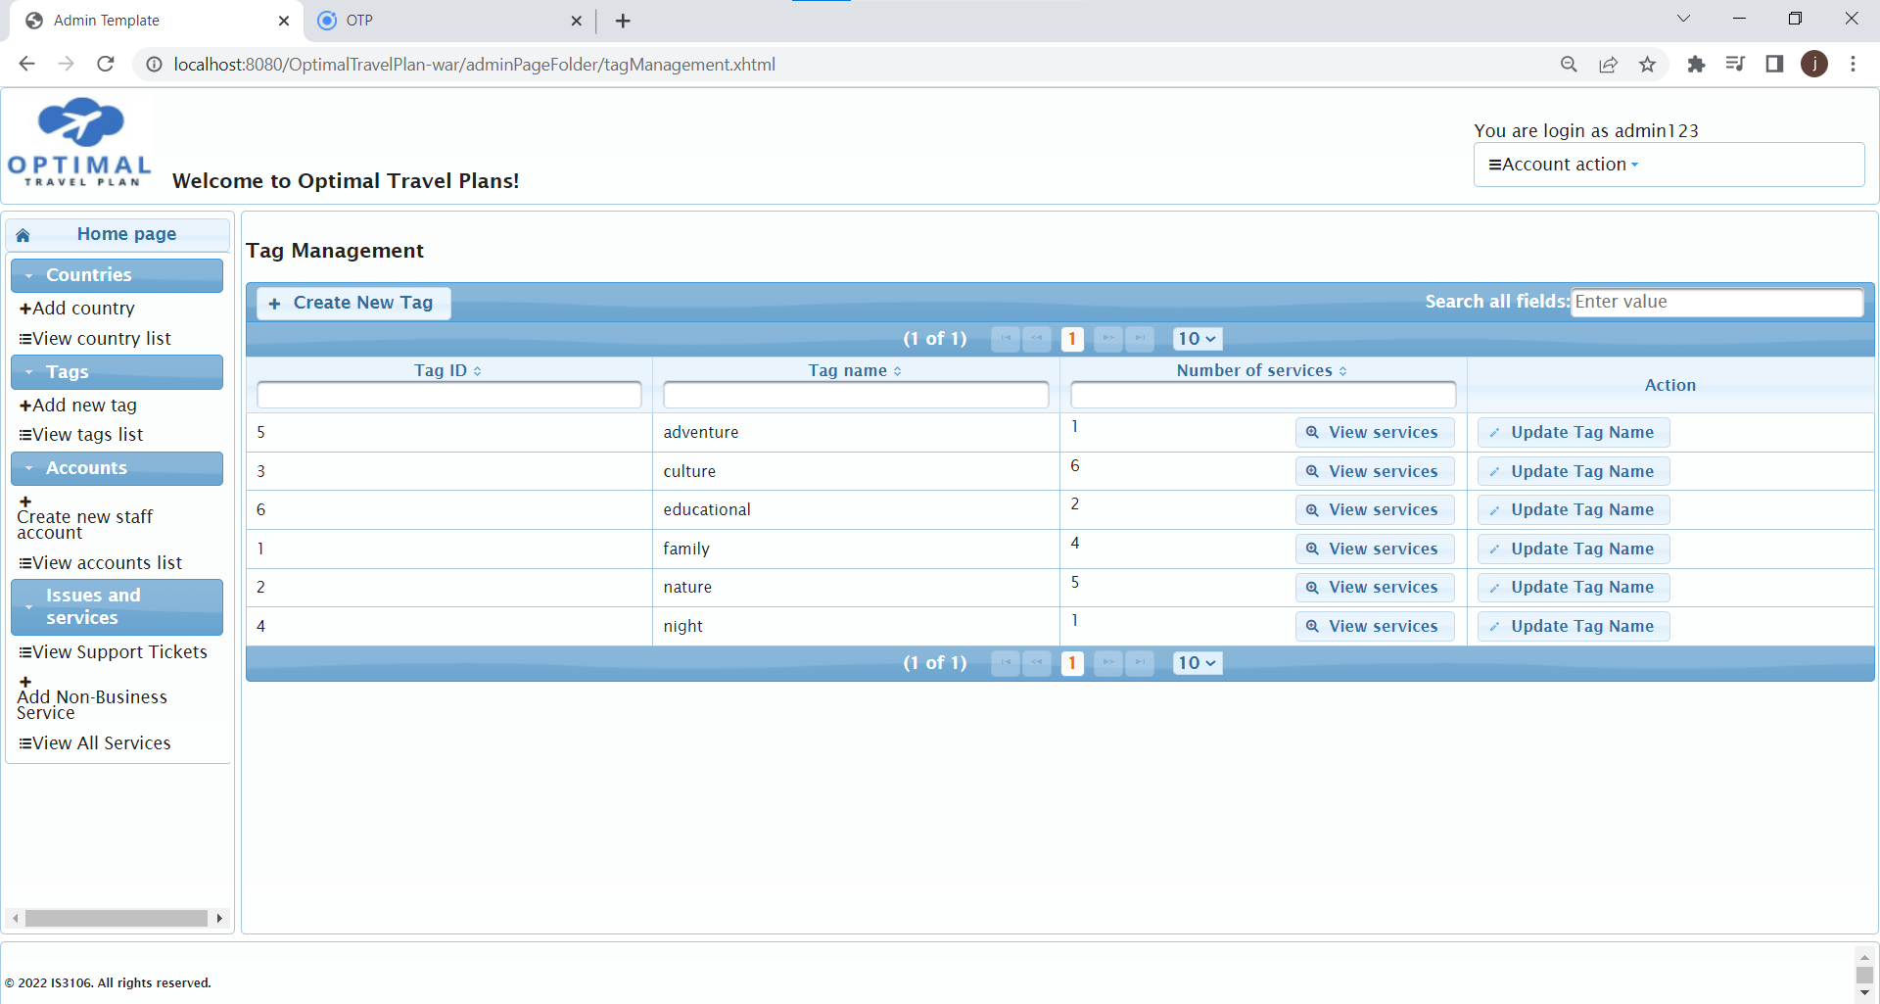

*Figure 9: Tag Management*

The Tags would allow the customers to indicate their interest tags to be recommended when the customer selects “recommended travel itinerary”. The staff of Optimal Travel Plan would be able to create, amend and delete the tags available. However, the deletion of the tags would only be allowed if there are no services listed by businesses under the tag.

#### Create/View/View a list of/Update/Disable Account

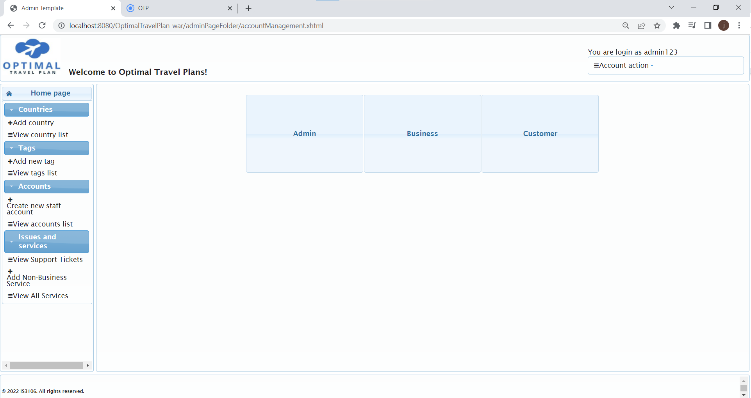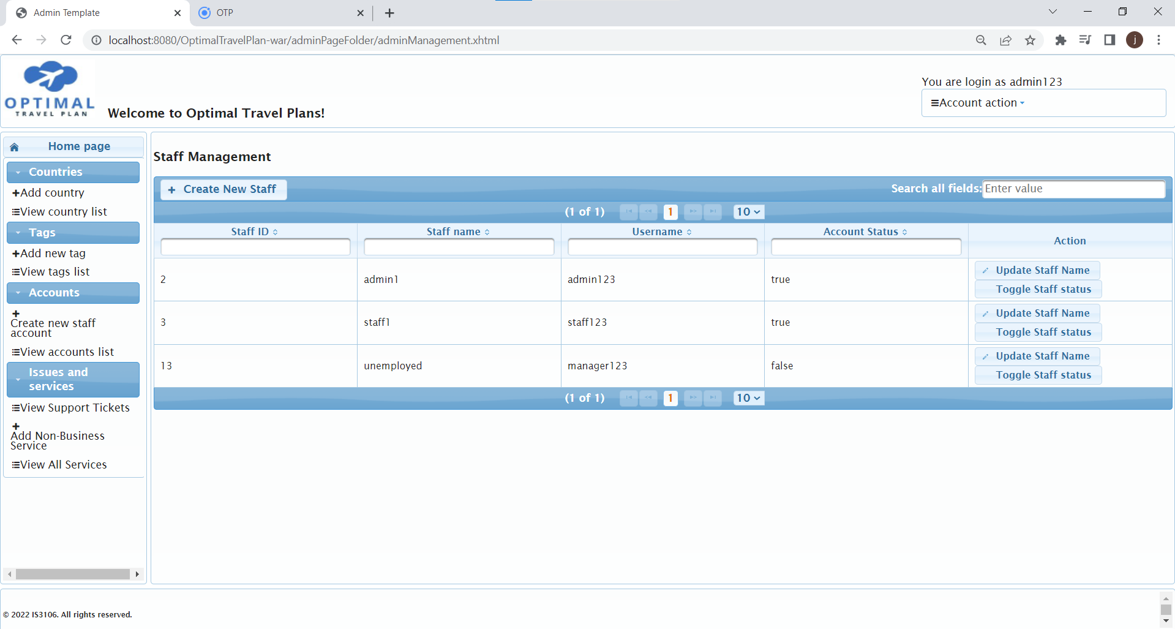

*Figure 10: Select accounts Figure 11: Staff Management*

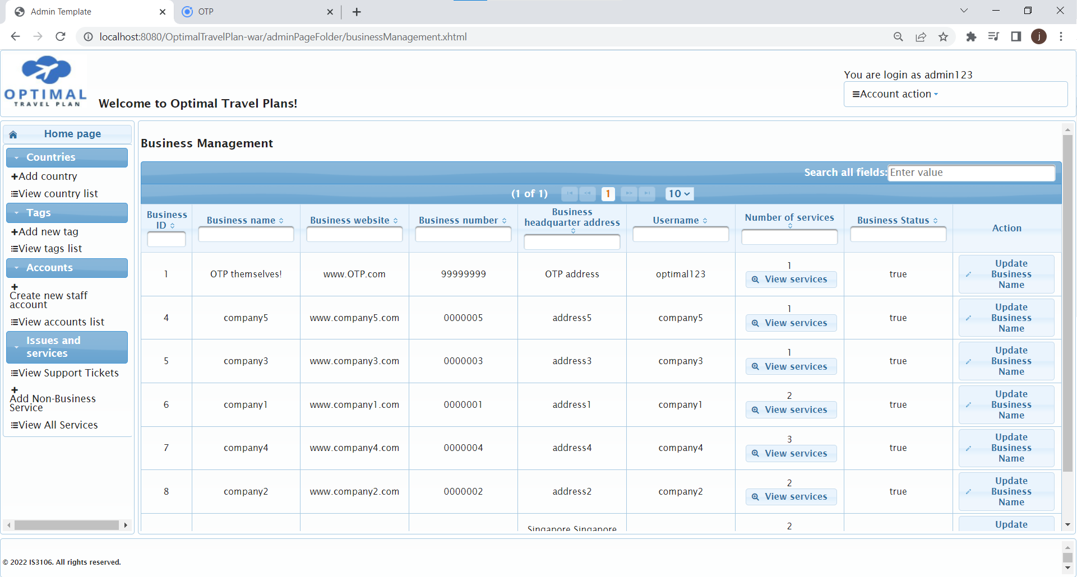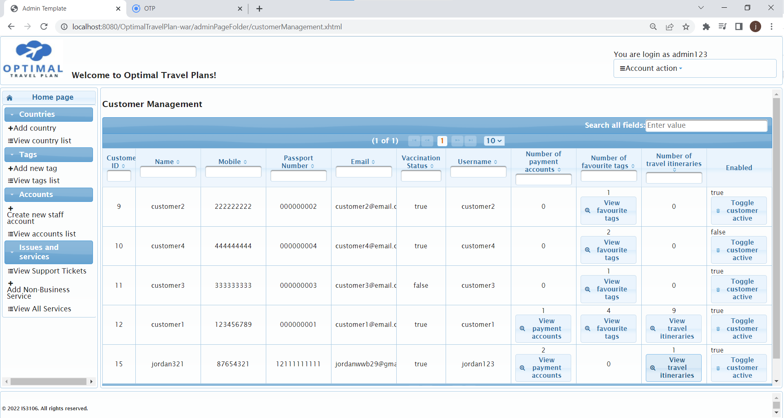

*Figure 12: Business Management Figure 13: Customer Management*

The accounts management page provides a dummy proof way for system admins to maintain accounts, from admin accounts to business or client accounts. This would support business processes such as hiring new admin staff as the Optimal travel plan grows, disabling accounts for reasons such as admin staff no longer working in the systems, or customer requests to disable their accounts due to information leak. Business accounts may also be disabled if admin deems there to be a legitimate reason such as unhonest business conduct or other reasons.  
As such, admins can ensure the security and user experience for users of the platform, both client and business, by eliminating the worries that both parties may have with respect to accounts.

#### View/View a list of/Resolve Support Requests

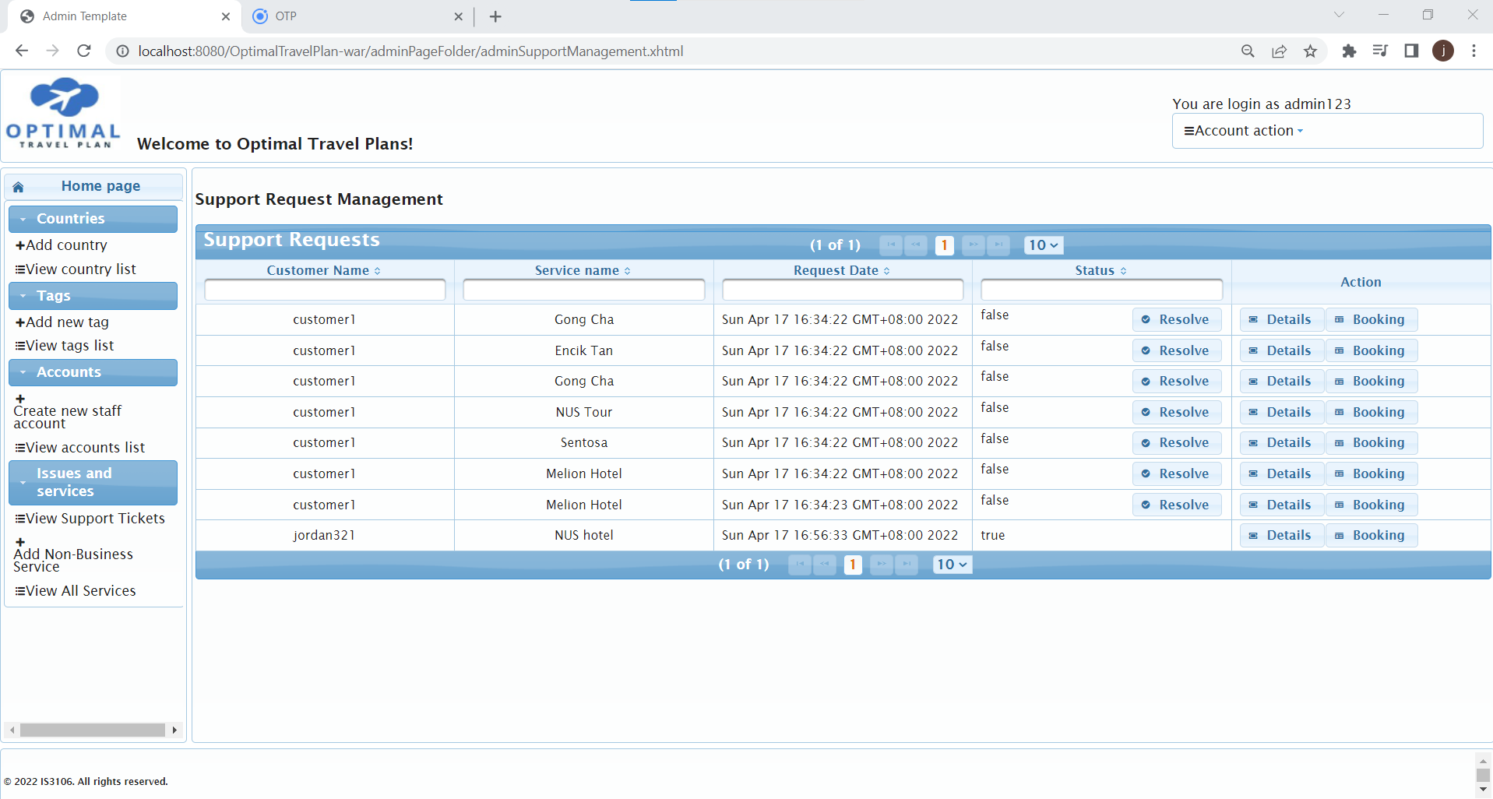

*Figure 14: Support Request Management*

As user experience is held as one of the highest priority, the support request management page would provide all functionality to view details of the booking, client and business. Thus the admin would have the information to make decisions on how to resolve the issue. This may include contacting the business, adding messages on the issue to chat with the customer. After confirming that customers are satisfied, the admin may then resolve the issue. Old support requests will still be saved on this page, but this would not be an issue as admins may filter for only unresolved issues.

#### Add comment to Support Requests

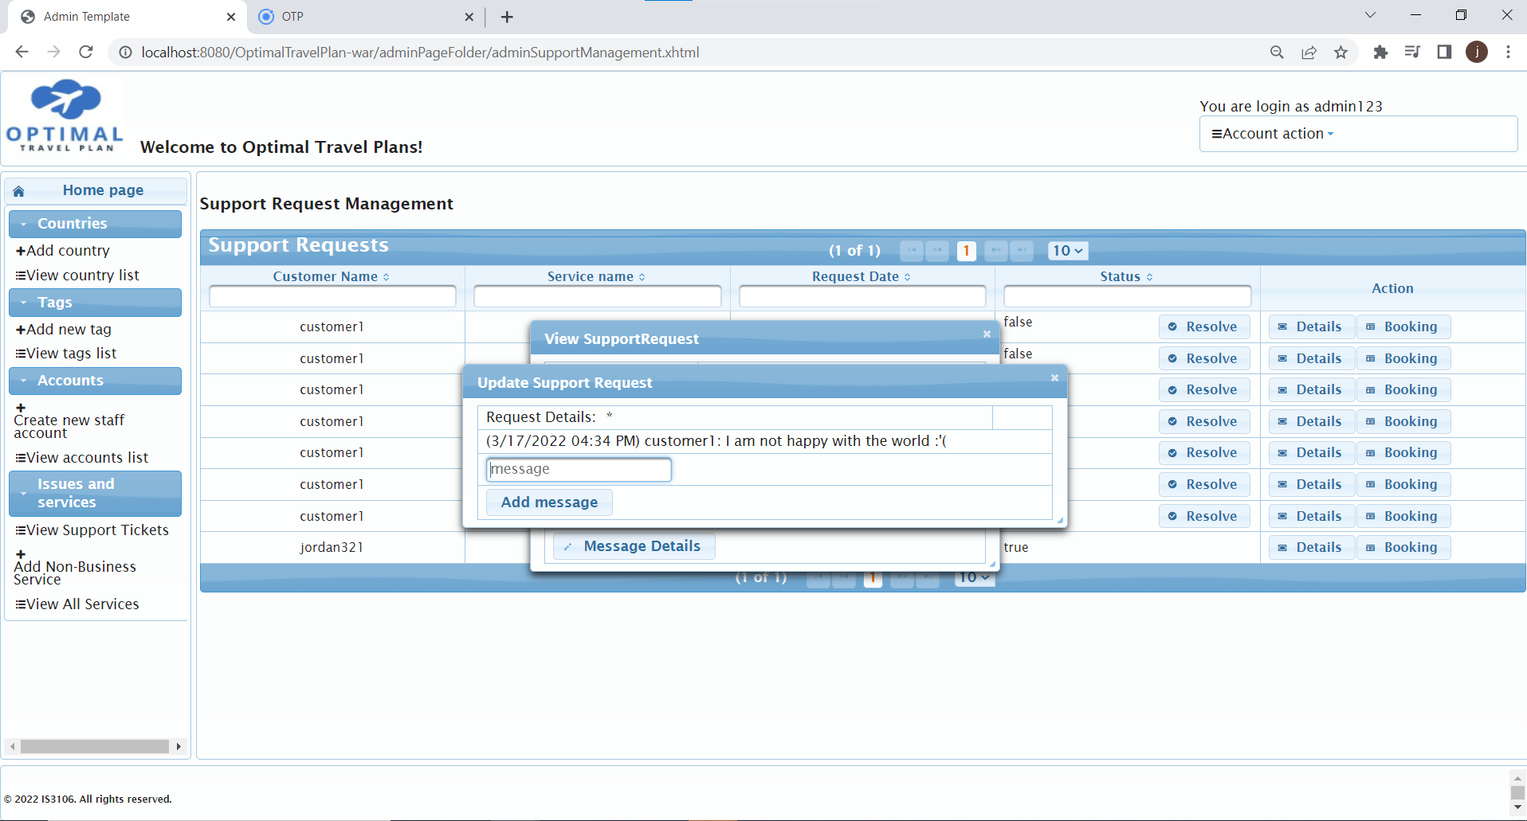

*Figure 15: Resolve Support Request*

The staff of Optimal Travel Plan would have access to view and respond to each request accordingly. There would be a chat function enabling the staff and customer to communicate the issues faced while using our services. After the customer problem has been resolved and is satisfied with the service, the staff can select and resolve the request.

#### Create/View/View a list of/Disable Services

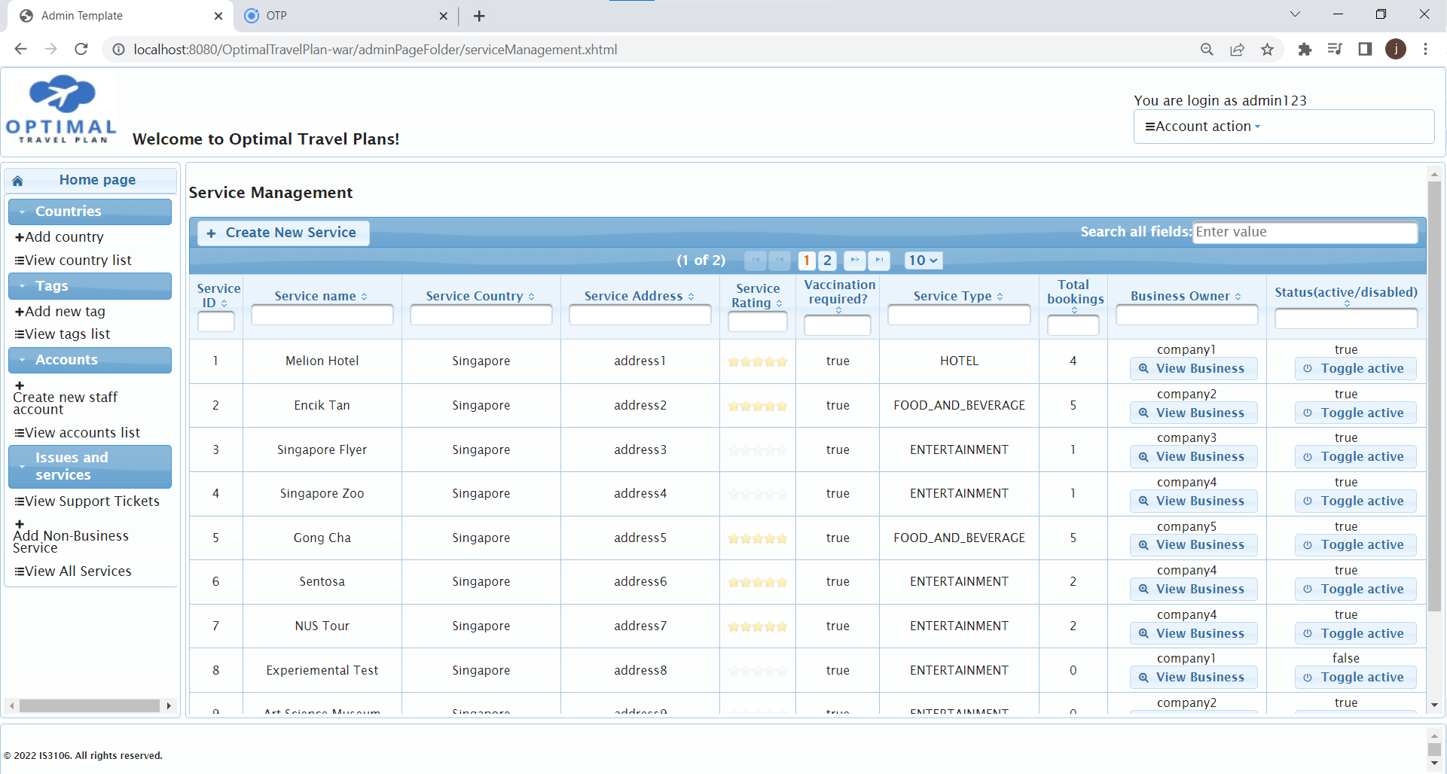

*Figure 16: Staff Service Management*

Admins may enter this page to view services, their details and businesses. They would also be able to disable the status of the services if they have been informed of an issue with the service.   
Admins may also view services of only a certain tag from the View tags list > View services (for that particular tag).

### **Business Interface submodule**

The core functions of this application is centred around the ability to manually build a personalised travel itinerary based on services that businesses have made, as well as (after selecting start and end dates) generate an editable travel itinerary. Email notifications will be sent during registration, forgetting of password, and payment. Customers are able to manage their account details, view available services, tags and countries, manage bookings, make reviews and receive replies, create support requests and partake in a chat-based system with the admin (on the JSF side), and view past transactions.

#### View Ratings, Income and Services Charts

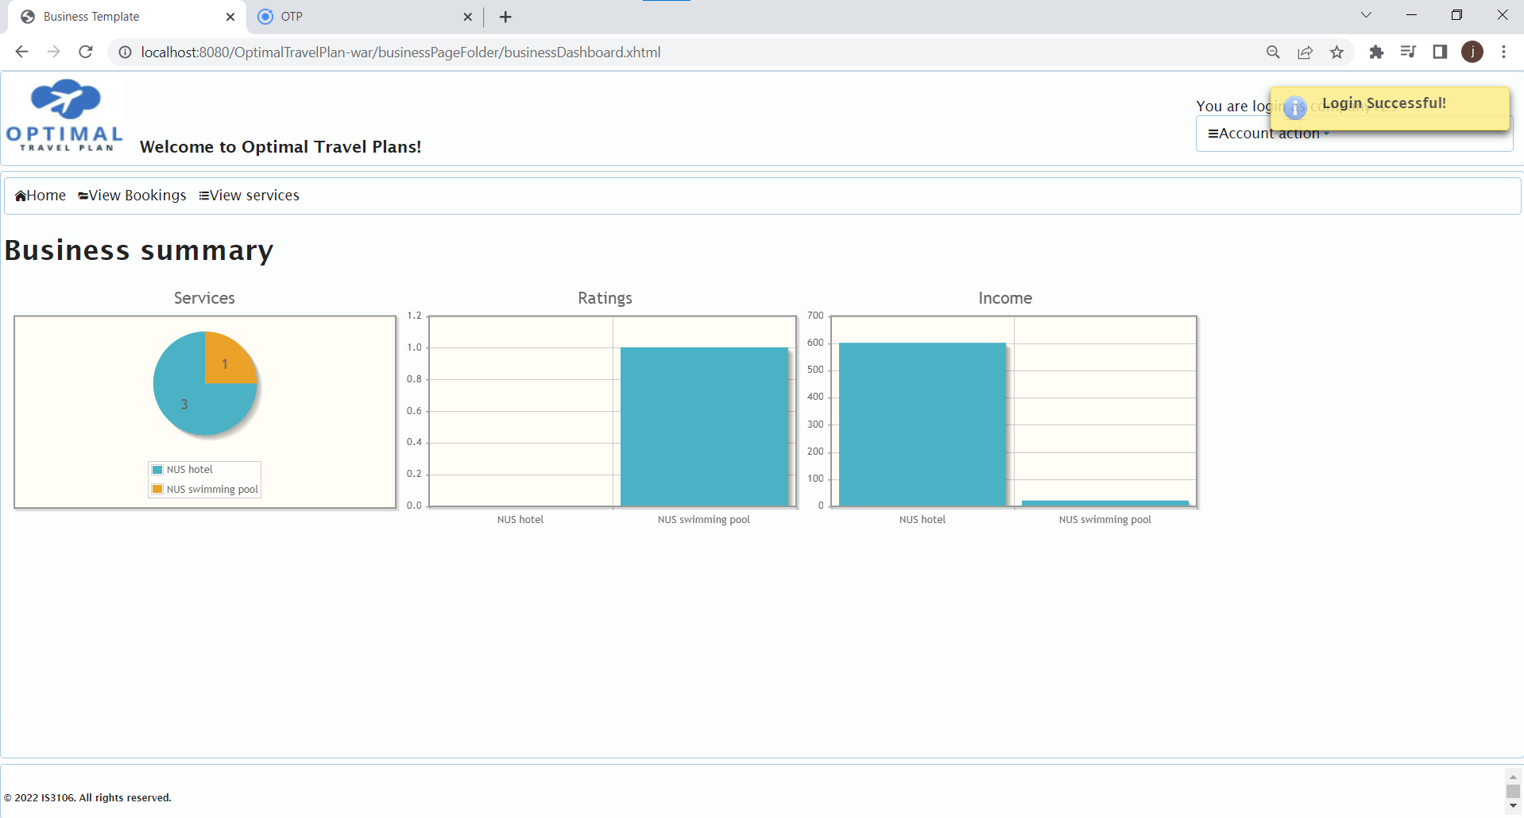

*Figure 17: Business Dashboard*

The business summary/dashboard is one of the key features to provide data summarised, aiding businesses in making decisions or simply understanding how their services are faring. This includes their average customer ratings, to total revenue from the service, to the popularity of their services or number of times the service is consumed. By providing these aggregate data, it would make businesses life easier in data collection, retaining their usage of Optimal Travel Plan to get customers and increase the likelihood of adding more of their services on OTP, allowing us to further increase the range of choices to customers.

#### Create/View/Update/Delete Account details (contact info/address)

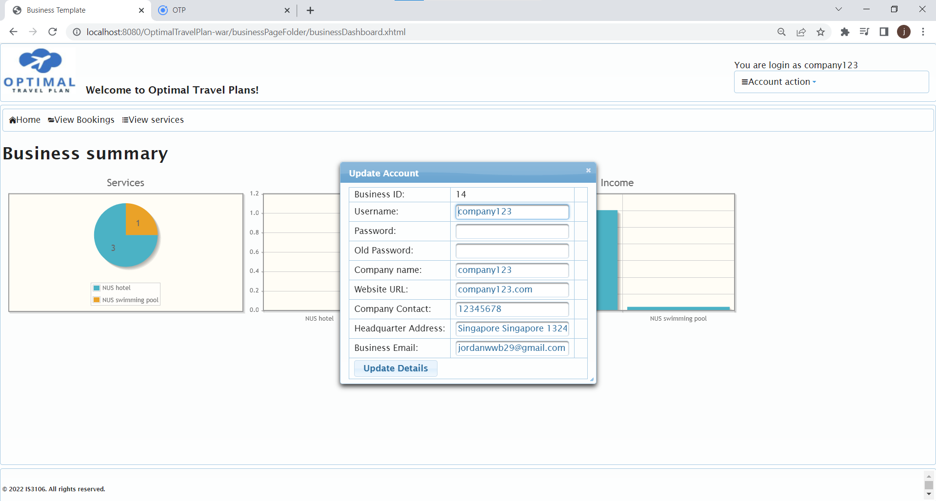

*Figure 18: Business Account Details*

The businesses would be able to view their current account details and make the appropriate amendments as required. For example, if the company has rebranded their company and has changed their business name, they would be able to update the details accordingly.

#### Create/View/View a list of/Update/Disable Service

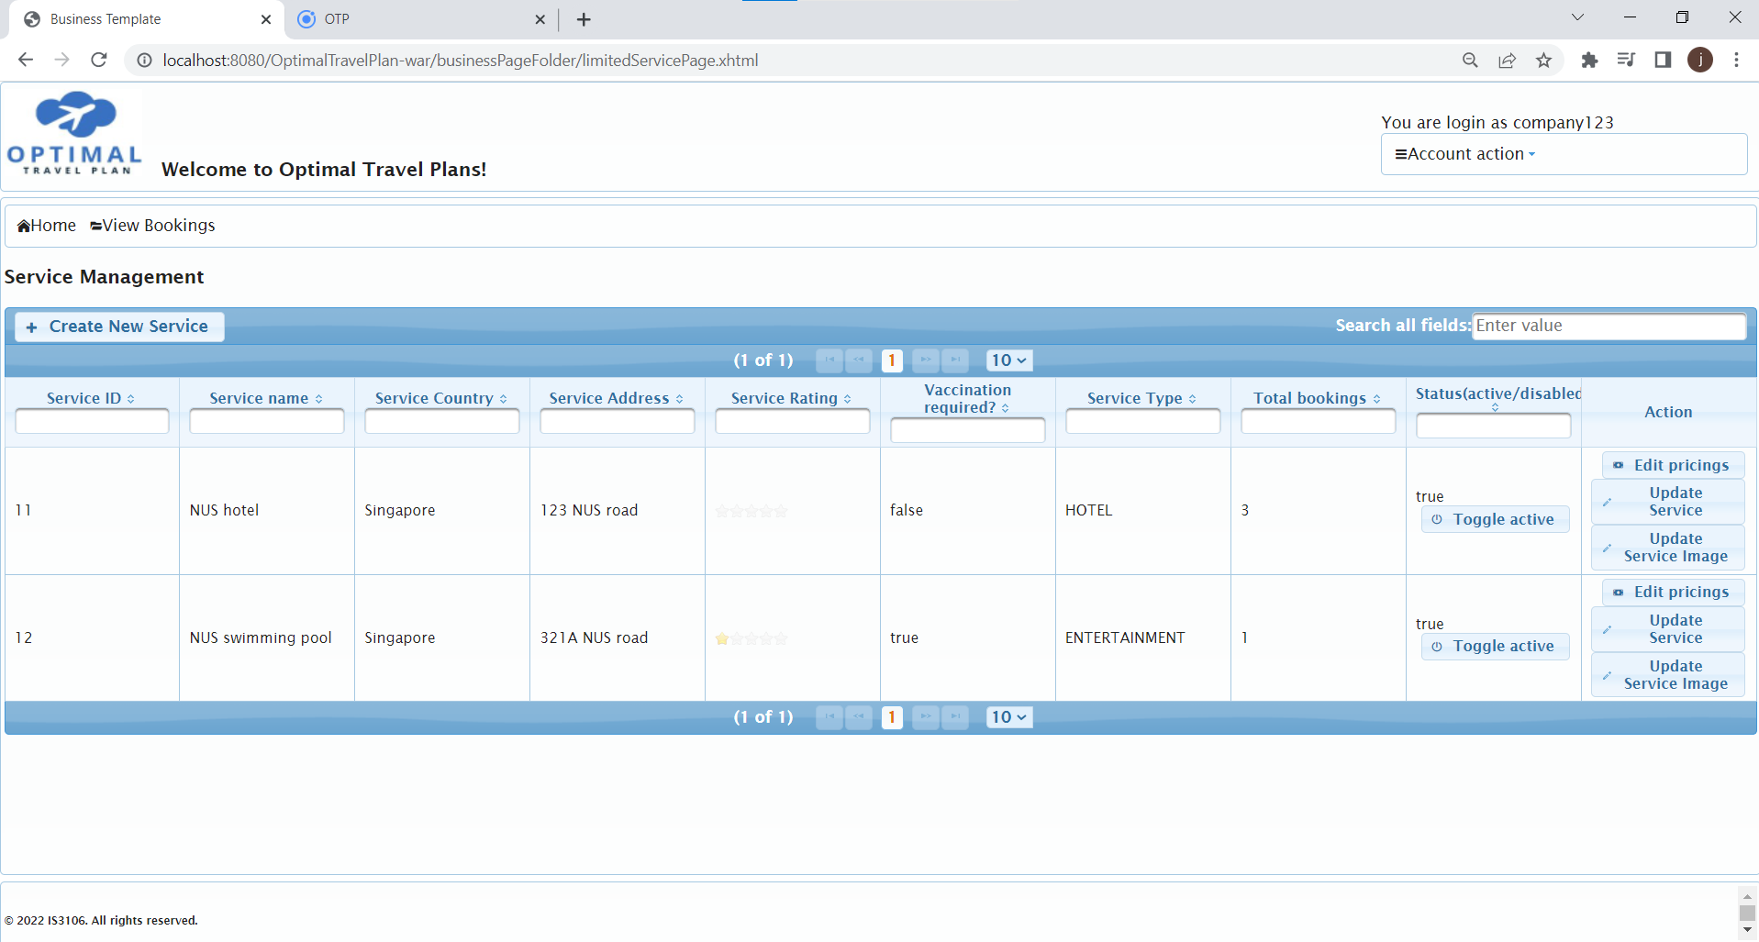

*Figure 19: Business Service Managemen***t**

The business would have full control over the services they would like to list on Optimal Travel Plan. They would be able to create, amend and disable their services. The businesses can create a new service by specifying the service name, vaccination requirements, address, country, tags and service type. Similarly the businesses can make the appropriate amendments to the details of the selected service.

#### View/View a list of Booking Details

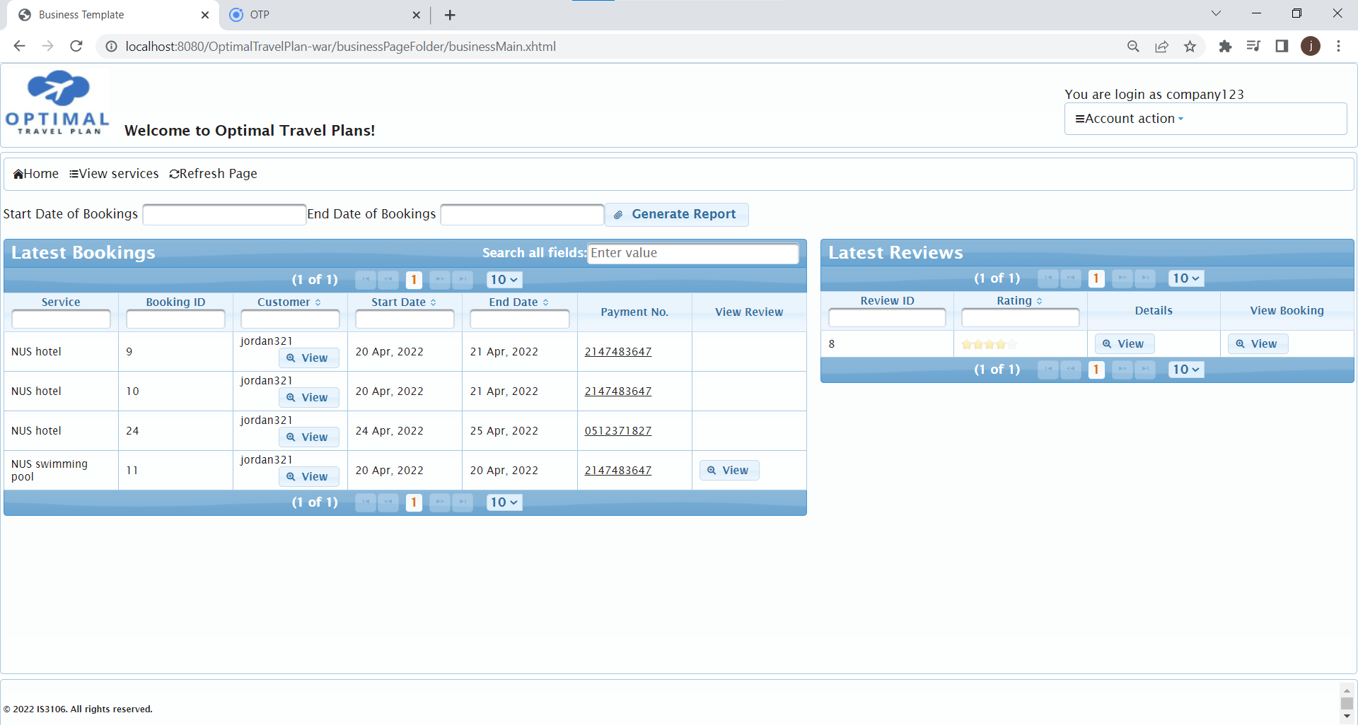

*Figure 20: Business Booking Management*

Here a business admin is able to view a list of Booking details. This includes the service name, customer details for the associated customer, start and end date, as well as payment transaction details. Each of these fields can be filtered by keyword. The “View” buttons in the “View Review” column enables the business admin to filter for reviews associated with the selected booking. This functionality helps the admin quickly identify associated reviews without additional searching. Note that this functionality is also present for the viewing of reviews to bookings, as explained below. To reset the page back to displaying the latest reviews after this filter, the admin can press the “Refresh Page” button at the menu bar at the top of the page.

#### View/View a list of/Reply to review

The Business Booking Management page allows the businesses to concurrently view the reviews of the services and the list of bookings associated with the reviews. The view button under View Bookings column would directly filter the list of bookings and display the booking associated with the selected review. The businesses can then select the view button under Details to view the comments posted by the customer. The platform allows the businesses to appropriately respond to such reviews (positive or negative) as a form for communication with the customer.

#### Generate Booking Report

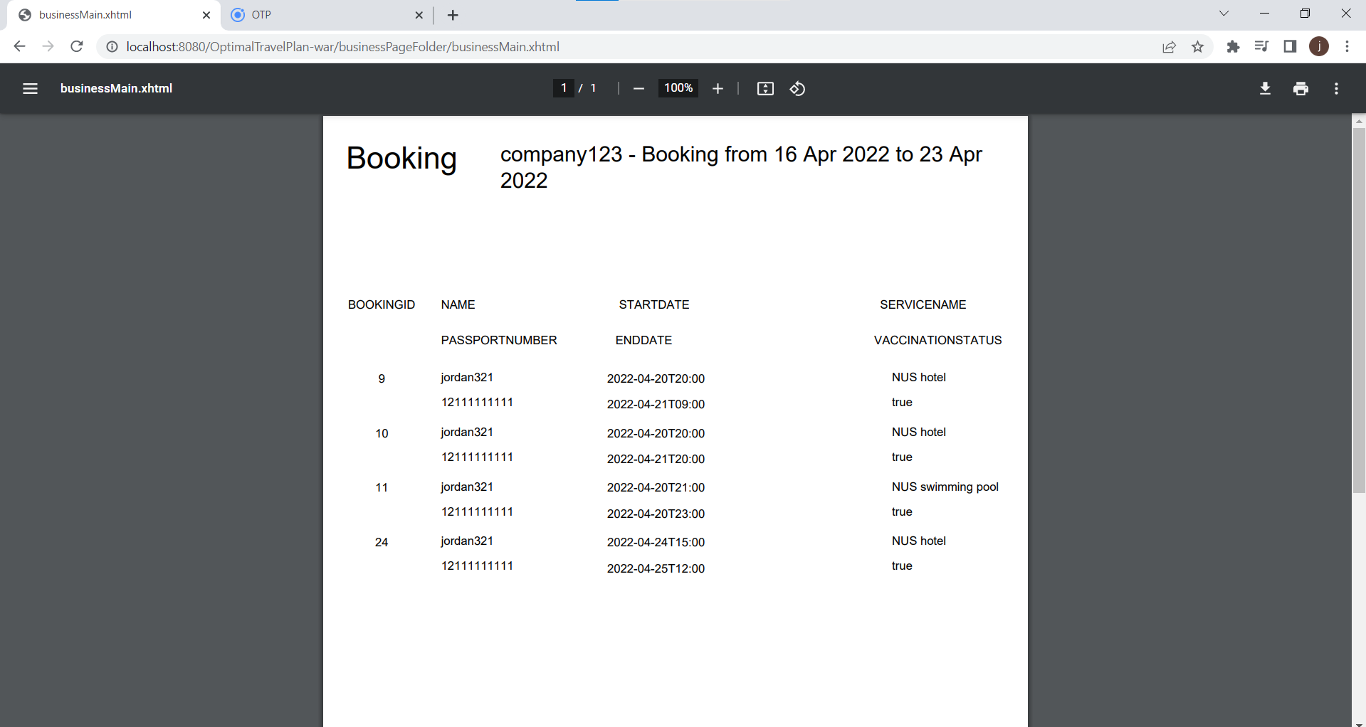

*Figure 21: Jasper Report*

The generate-booking report allows the business to generate a report of bookings, making it easy to send or disseminate information to front counter customer management staff that may not have access to the business account. This brings convenience for higher management teams to provide information to lower level staff to prepare for customers that they may be expecting. This includes vital information such as start and end date of the booking, the customer they are expecting, the service paid for by the customer, and customer passport to verify the customer. This would only allow businesses to be better prepared for customers, and also improve the experiences of customers, which would in turn give good feedback to the business. By achieving better user experience, we will be able to attract and retain more business and customers, further allowing OTP to expand our market share.

#### Create/View/View a list of/Disable Service Rate

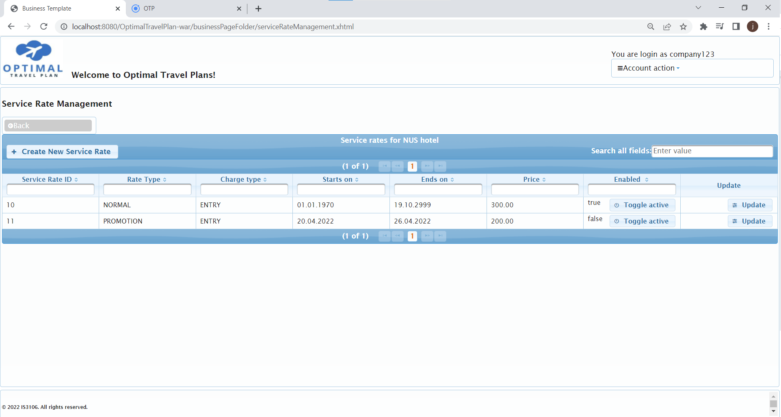

*Figure 22: Service Rate Management*

From the page that allows the admin to view a list of services, clicking the “Edit pricings” button will lead to this page. Here, the admin is able to view details of all available service rates added by him/herself for that particular service. The admin is also able to create a new service rate. Note that upon creating a new service rate for a service that does not have any yet, the admin will only be able to create a NORMAL_RATE. This is a default rate with no start and end date. Otherwise, the admin is able to create rates with rate types of either NORMAL, PEAK and PROMOTION. The charge types available include ENTRY and HOURLY, to accommodate for the different types of services that might require either. After the above information is put in, a price, start date, and end date can be selected and creation can be initiated.

The admin is also able to toggle created services rates between enabled and disabled. Additionally, the admin is able to update current service rates to change its rate type, charge type, start date and end date. Note that the edited start date cannot exceed the original start date and the edited end date cannot exceed the original end date. This is so as to not interfere with current services currently being utilised with the current edited rate.

## **User interface 2: Ionic**

The hybrid mobile application will be designed for customers to use our platform to access our services. Customers are able to handle basic profile management tasks such as account details updating, choosing a list of favourite tags, managing payment methods and viewing and filtering for past transactions and bookings. The main business function of this application is provided in the travel itinerary details page. A non-logged in customer is able to play around with an itinerary, viewing services (and their reviews) and adding them to it. This itinerary will not be saved unless the customer does a login. Afterwhich, the customer may also choose to have a travel itinerary recommended to him/her according to the dates that they determine. Payment can then be made on all predefined bookings. Email notifications will be sent to the Customer’s email address upon registration, sending of recovery email for a forgotten password, payment of bookings in the travel itinerary, and finally the resolving of a support request on the JSF side.

**Application screenshots:**

NOTE: The order of the following screenshots and descriptions are almost sequential. It can be assumed for some of the pages that the diagram directly afterwards is a direct result of a function that happened in the previous diagram. This does not apply for everything.

#### Index Page

New customers are recommended to spend some time browsing the demo section of this page to learn more about the functionalities of this application. A slide show is provided that outlines the general usage flow for a typical customer.

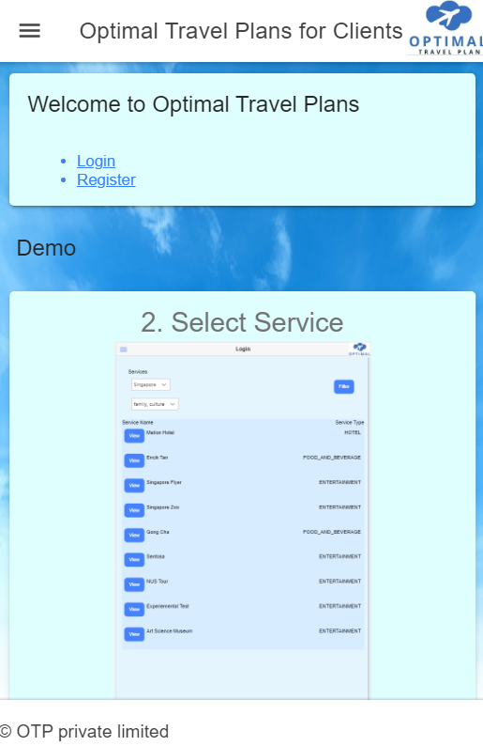

*Figure 23: Index Page*

#### Register as Customer

A customer provides valid details to be able to register successfully. A confirmation email will be sent to his/her email address upon successful registration. Upon failure, appropriate error messages will be displayed.

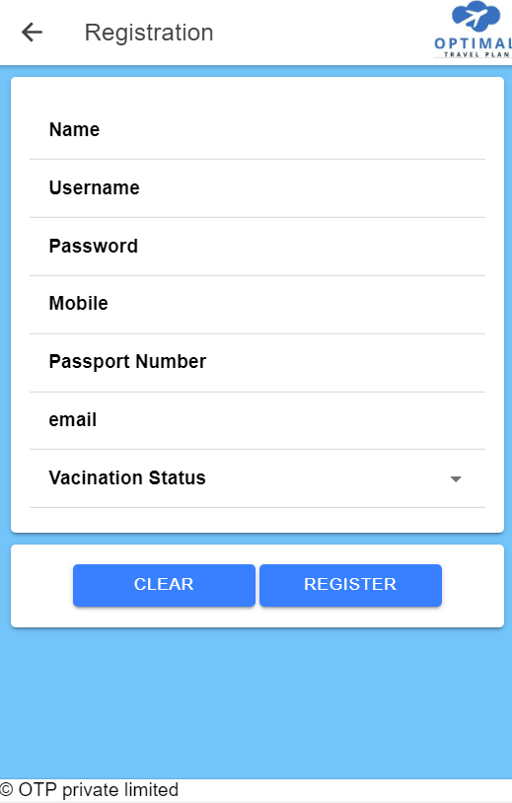

*Figure 24: Registration*

#### Login

The user logs on with a valid username and password, failure to do so results in displayed error messages. Clicking “FORGOT PASSWORD” and inputting an invalid email address results in an error, a valid email address will result in an email being sent to the user with the associated username and a randomly generated password, prompting him/her to login and change password.

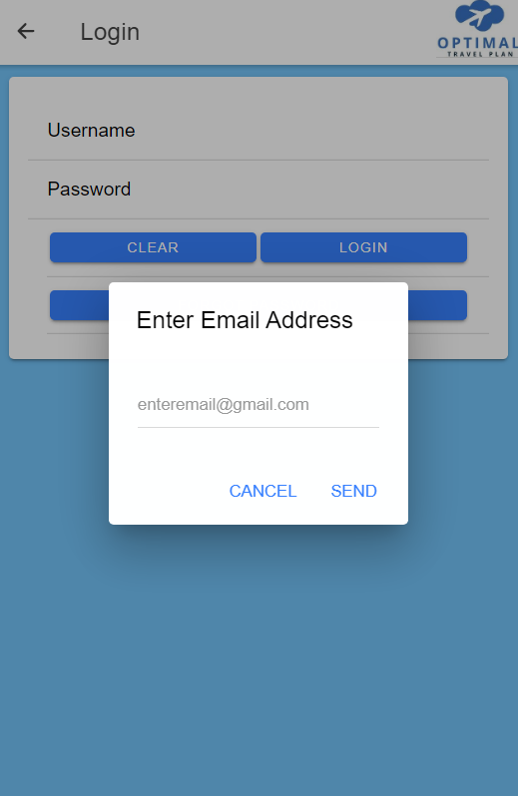

*Figure 25: Login and forget password*

#### Side Menu

A beautifully designed side menu bar designed for maximum usability. This modern interface provides the best of both worlds in terms of aesthetics and functionality.

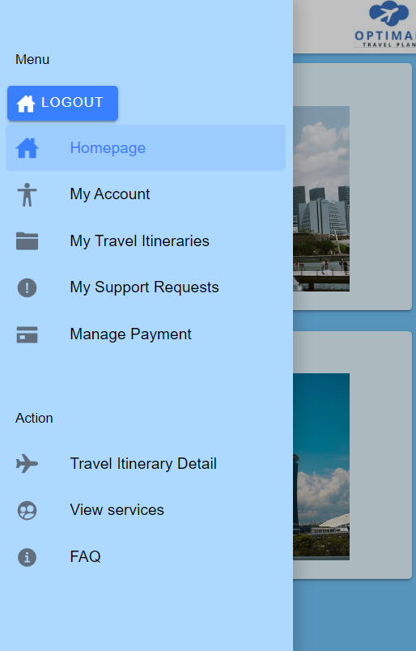

*Figure 26: Side Menu*

#### Home Page

The customer can view slideshows of countries and attractions. A list of available countries and tags are also displayed here. This serves as an attractive starting page.

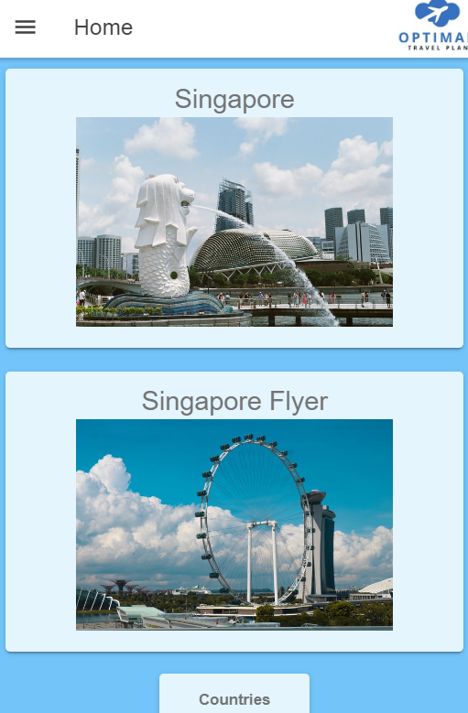

*Figure 27: Home Page*

#### My Account

Here, the customer can update the details of his/her associated account. Modifications of details, including removing and adding favourite tags will require the user to press “SAVE CHANGES” to persist. “CHANGE PASSWORD” requires the input of the old password. The “MANAGE PAYMENT” button will navigate to the Payment Management page in the Manage Payment section.

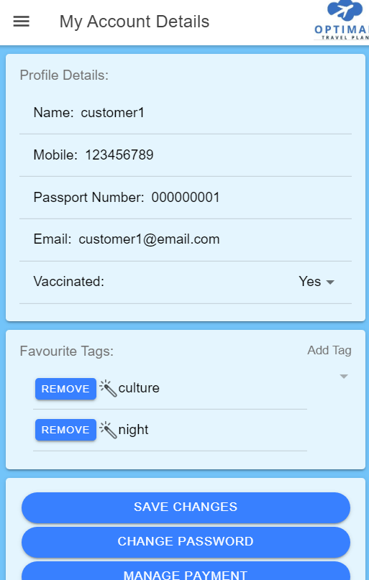

*Figure 28: View my Account Details*

#### My Travel Itineraries

Here Customers can view all associated travel itineraries. Customers can navigate to the individual itinerary details via this page. Customers can also navigate to the creation of a new travel itinerary via this page as well create a support request for an existing itinerary. The below diagram is after pressing the “VIEW DETAILS” button of a selected travel itinerary.

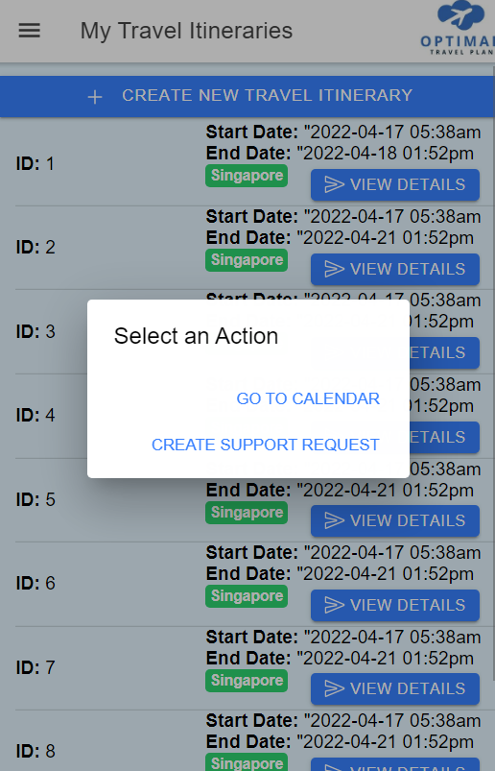

*Figure 29: My Travel Itineraries*

#### Create Support Request

The customer specifies details on the issues of the travel itinerary and selects a booking to create the support request for. If the booking already has an associated supported request, an error message will be shown. If not, a support request will be made and the admins on the JSF side will be able to comment and possibly resolve the support request. Customers can view and reply to comments by the admins in the “View a Support Request’s Details” page

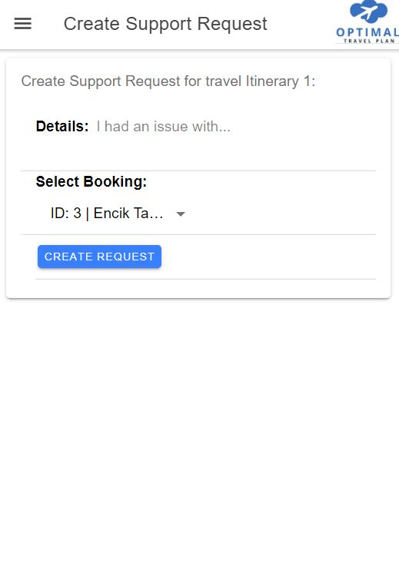

*Figure 30: Create Support Request for a booking in an itinerary*

#### View All my Support Requests

Here a customer can view resolved and unresolved support requests. Support requests already resolved by the admins on the JSF side will display here as RESOLVED. Selecting a support request will lead to the view support request details page.

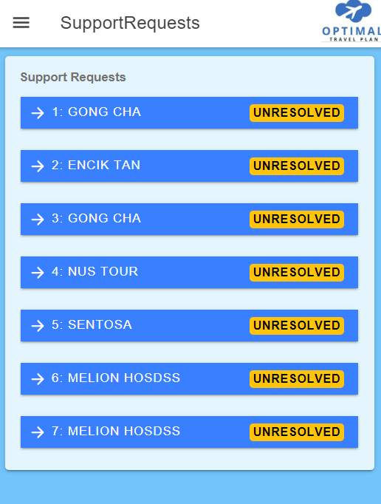

*Figure 31: View All My Support Requests*

#### View a support request’s details

If a support request remains unresolved, the user will be able to continue writing comments and communicating with the admin on the JSF side. If it is resolved, this function will cease to exist.

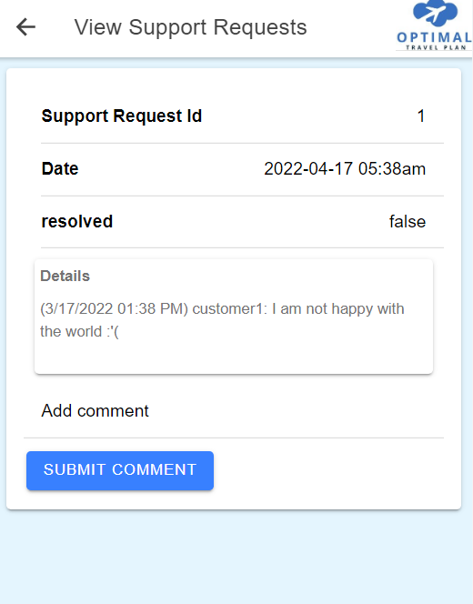

*Figure 32: View a Support Request’s Details*

#### Manage Payment

The customer is able to add and remove payment accounts as well as view and search for past transactions. Searching filters transactions by the transaction number, date, and account number. Booking details can be seen by clicking the blue search icon.

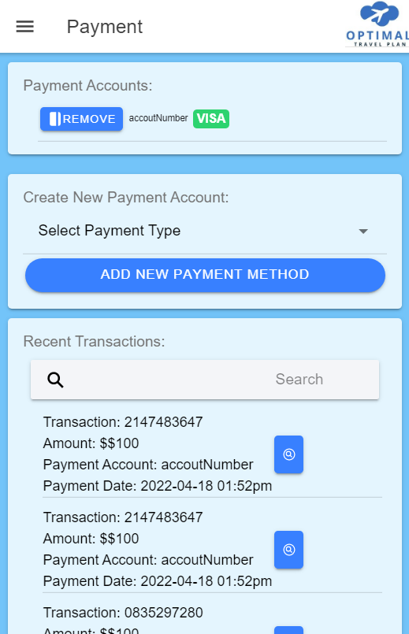

*Figure 33: Manage Payment Details and View Transactions*

#### Adding New Payment Method

After a new payment account type has been selected between VISA, MASTER, GRAB_PAY and CREDIT_CARD, the customer will be able to add a payment account.

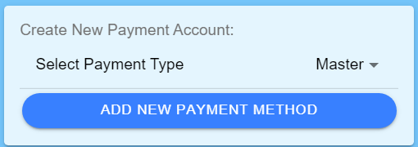

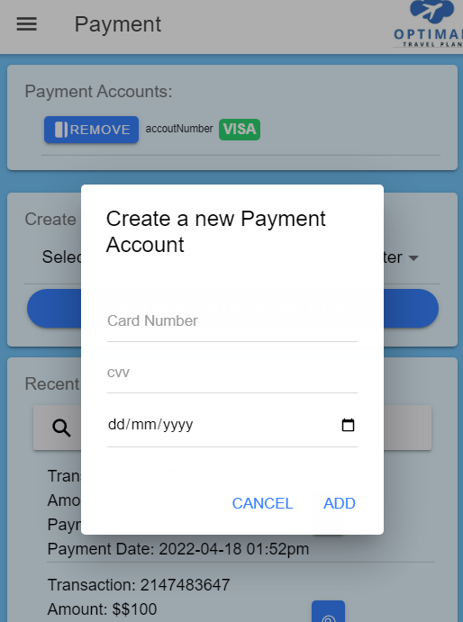

*Figure 34: Adding a new Payment Method*

#### View a List of Services

Here a customer is able to view all available services set by businesses on the JSF side. The customer is able to filter by tags, country, as well as keywords. Clicking “VIEW” will enable the customer to view each service details including its respective reviews and ratings.

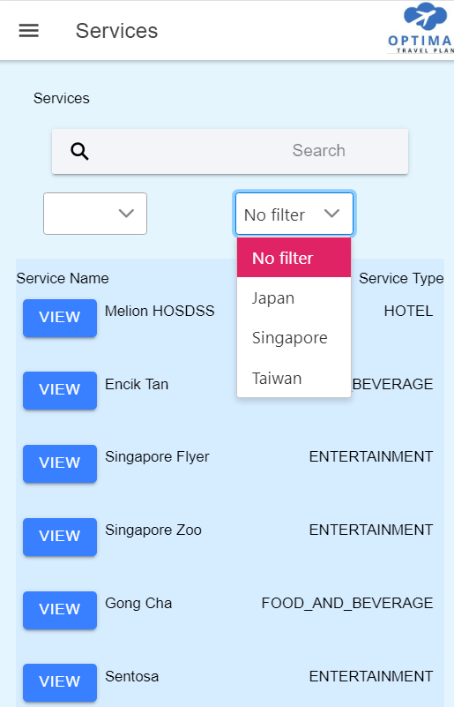

*Figure 35: View a List of Services*

#### View a Service’s Details

Here the customer is able to view the details of a service and add it to a travel itinerary if desired. Details include the payment type, associated tags, rating, as well as a scrollable list of reviews that can be expanded to display the review details as well.

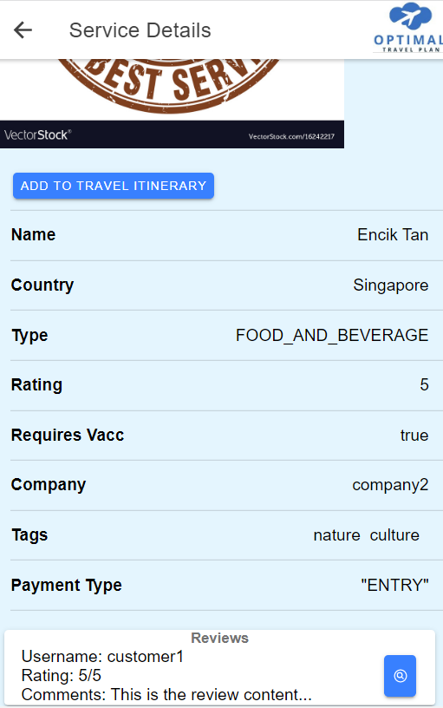

*Figure 36: View a Service’s Details*

#### View Travel Itinerary Details (Before Login)

The customer is able to add services to an empty travel itinerary before login. Only after login can the travel itinerary be saved.

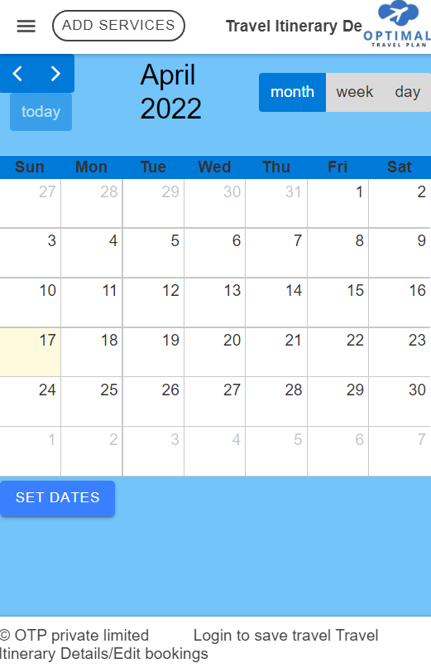

*Figure 37: Viewing Travel Itinerary details (Before Login)*

#### Generate a Travel Itinerary

After login, the customer gains access to a few more functionalities to the view travel itinerary details page. This includes setting the date for a travel itinerary and having one automatically generated. Here the customer is able to view the individual bookings in each travel itinerary. This is done by clicking “VIEW”.

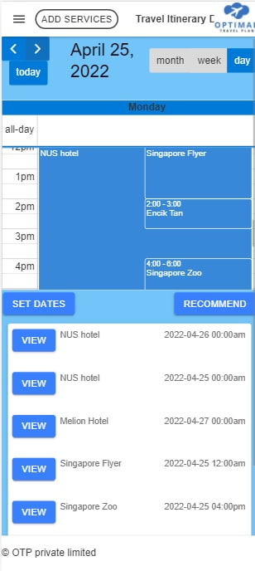

*Figure 38: Viewing Travel Itinerary details (After Login)*

#### View Booking Details in a Travel Itinerary

Here the customer is able to view details for a selected booking in a travel itinerary. The customer is then able to remove the booking, edit the booking dates, as well as view the service details for the specific service associated with the booking.

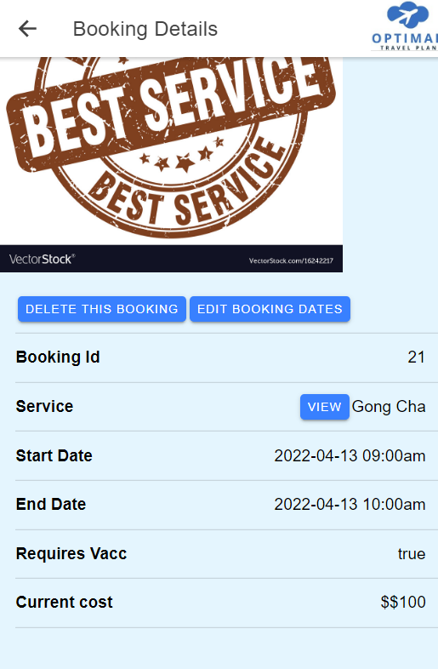

*Figure 39: Viewing Booking Details of a Booking in a Travel Itinerary*

#### Making Payment for a Travel Itinerary

In the travel itinerary details page, the customer is able to scroll all the way down and click the “CONFIRM PAYMENT” button. This prompts the customer to select a payment account to make a payment with. If no payment accounts have been added by a customer, the customer will be prompted to create a payment account first. Once payment is confirmed, an email will be automatically sent by the system to the email address associated with the customer account.

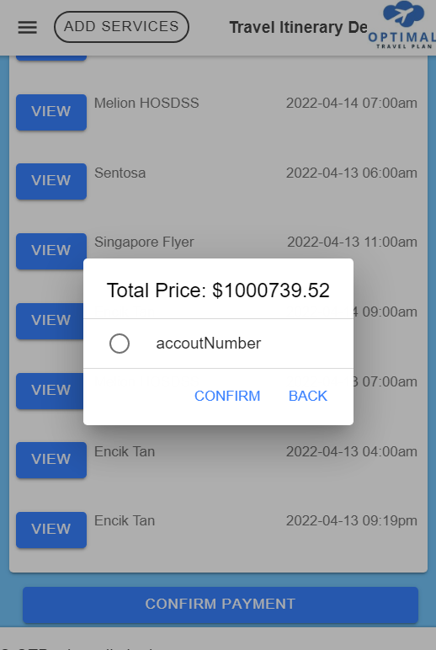

*Figure 40: Making Payment for a Travel Itinerary*

#### View FAQ page

This page provides the customer with answers to frequently asked questions, and a comprehensive list of instructions on how customers can use the web-application. Contact details are also provided here for further queries.

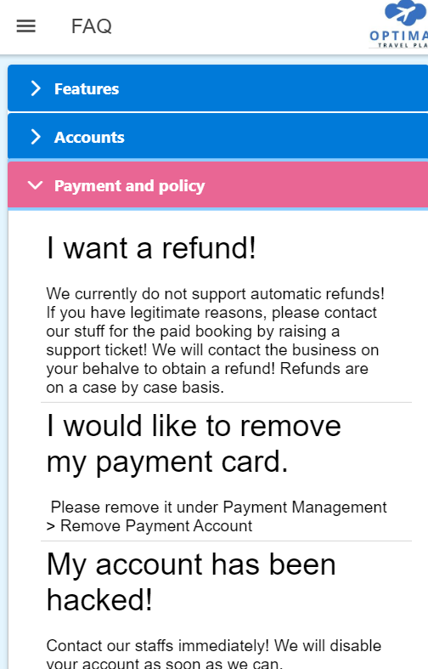

*Figure 41: FAQ Page*

# References

Adgate, B. “Agencies Agree; 2021 Was A Record Year For Ad Spending, With More Growth Expected In 2022”, *Forbes* [Online], December 8, 2021, accessed at [https://www.forbes.com/sites/bradadgate/2021/12/08/agencies-agree-2021-was-a-record-year-for-ad-spending-with-more-growth-expected-in-2022](https://www.forbes.com/sites/bradadgate/2021/12/08/agencies-agree-2021-was-a-record-year-for-ad-spending-with-more-growth-expected-in-2022/?sh=22443af27bc6) on April 15, 2022.

BBC Travel. “The new normal? Travel in the world of Covid-19”, *BBC Travel* [Online], 2022, accessed at <https://www.bbc.com/storyworks/travel/travel-on/the-new-normal-travel-in-the-covid-19-world> on April 15, 2022.

Google. “How Search algorithms work”, *Google Search* [Online], 2022, accessed at <https://www.google.com/search/howsearchworks/algorithms/> on April 16, 2022.

Google Ads. “How to Use Google Ads to Reach Your Goals”, *Google Ads* [Online], 2022, accessed at <https://ads.google.com/intl/en_sg/home/how-it-works/> on April 16, 2022.

Holder, J. “Tracking Coronavirus Vaccinations Around the World”, *The New York Times* [Online], April 11, 2022, accessed at <https://www.nytimes.com/interactive/2021/world/covid-vaccinations-tracker.html> on April 16, 2022.

Inspirock. “Trip Planner: Plan &amp; manage your vacation itinerary on Inspirock”, *Inspirock* [Online], 2022, accessed at <https://www.inspirock.com/> on April 15, 2022.

Instagram. “Instagram Ad Solutions”, *Meta for Businesses* [Online], 2022, accessed at <https://business.instagram.com/ad-solutions> on April 16, 2022.

Lim, V. “Nearly S$500 million set aside to support Singapore’s tourism recovery”, *CNA* [Online], April 6, 2022, accessed at <https://www.channelnewsasia.com/singapore/singapore-tourism-recovery-support-stb-covid-19-singaporeimagine-grants-2610691> on April 15, 2022.

Organisation for Economic Co-operation and Development. “Internet access”, *OCED Data* [Online], 2021, accessed at <https://data.oecd.org/ict/internet-access.htm> on April 16, 2022.

Pew Research Center. “Social Media Fact Sheet”, *Pew Research Center* [Online], April 7, 2021, accessed at <https://www.pewresearch.org/internet/fact-sheet/social-media/> on April 16, 2022.

Semrush. “Google.com Web Traffic Statistics”, *Semrush* [Online], 2022, accessed at <https://www.semrush.com/website/google.com/> on April 16, 2022.

Singapore Tourism Board. “Singapore’s tourism sector remained resilient in 2021, ready for recovery in 2022 and beyond”, *Singapore Tourism Board* [Online], January 25, 2022, accessed at <https://www.stb.gov.sg/content/stb/en/media-centre/media-releases/Singapores-tourism-sector-remained-resilient-in-2021-ready-for-recovery-in-2022-and-beyond.html> on April 15, 2022.

United Nations World Tourism Organisation. “Tourism Enjoys Strong Start to 2022 while Facing New Uncertainties”, *United Nations World Tourism Organisation* [Online], March 25, 2022, accessed at <https://www.unwto.org/news/tourism-enjoys-strong-start-to-2022-while-facing-new-uncertainties> on April 15, 2022.

Wanderlog. “Wanderlog: best free travel itinerary & road trip planner app”, *Wanderlog* [Online], 2022, accessed at <https://wanderlog.com/> on April 15, 2022.

We are Social. “Special Report - Digital 2022”, *We are Social* [Online], 2022, accessed at <https://wearesocial.com/sg/blog/2022/02/digital-2022/> on April 16, 2022.

# Appendix

Link to Diagram PDF document for clearer images: <https://drive.google.com/file/d/1fRROOGhY9EnioaxWCfmM72JGsjz2CT5f/view?usp=sharing>

Link to Demonstration Video: <https://youtu.be/mLk0G76gVgo>

*Demo Checklist*

| JSF (admin) | | |
| --- | --- | --- |
| No. | Details | Check |
| 1 | Login as Admin Login  Username: manager1  Password: password | Login function for admin |
| 2 | View country and Update Taiwan  Name: Republic of china | Correct country names :D |
| 3 | Create new Country  name: Indonesia | Creating new Country |
| 4 | Delete republic of china | Deleting a country |
| 5 | Add tags button  Name: newTag123 | Create new Tag |
| 6 | Delete tag  Name: newTag123 | Delete unused tag |
| 7 | Update tag “empty test tag”  Name: “educational” | Update tag name |
| 8 | View service for culture tag | Viewing of culture tag services |
| 9 | Refresh all service  Select view all latest services | Refresh and displays all services |
| 10 | View all services and filter “Experimental”  Enter Experimental in the filter column | View and filter services |
| 11 | Toggle Experimental Test to inactive  Select Toggle active button | Disable a service |
| 12 | View business details for service Singapore Zoo  Select the View Business button under Singapore Zoo | View all business |
| 13 | Add Non- business Service  Service name: botanic garden  Required vaccination: false  Service address botanic garden  Country: Singapore  Tags: nature | Create new non-business service |
| 14 | View all staff  Select view accounts list followed by Admin | View all staff |
| 15 | Create new Account staff  Name: manager123  Username: manager123  Password: password | Create new staff account |
| 16 | Update Employee  Rename Manager123  Name: unemployed | Update staff account name |
| 17 | Disable Employee  Toggle unemployed employee to inactive | Disable staff account |
| 18 | Update account  Select Account Action and Update Account  Change  Username from manager1 → admin123,  Password : password1  Old Password: password | Update username and password |
| 19 | View all Customers  Select view accounts list and Customer | View all customers |
| 20 | View payment accounts of customer1  Select View payment accounts under customer1  View tags and travel itineraries of customer1  Select View favourite tags under customer1  Select View Travel itineraries under customer1  Toggle and disable customer4  Select Toggle Customer active for customer4 | View details of the customer |
| 21 | Logout  Select Account action and Logout | Logout of an account |
| JSF Business | | |
| 22 | (start from index page)  Register as business  username: company123  Password: password  Company name: company123  Company website: company123.com  Company number: 65432178  Company country: Singapore  Company city : singapore  Company postal: 123456  Company email: company123@email.com | Register a business account |
| 23 | View all services  Select View Services | View all services |
| 24 | Create new service  Service name: NUS hotel  Required vaccination: true  Service address: 123 NUS road  Country: Singapore  Tag: family and adventure  Service type: Hotel | Create new service |
| 25 | Create a normal service rate for NUS Hotel service  Charge type: ENTRY  Price: 300  *The first service rate is the general rate that lasts forever. So unable to choose start and end date. | Create a normal service rate |
| 26 | Create a promotion service rate for NUS Hotel service  Rate Type: PROMOTION  Charge type: ENTRY  Price: 200  Start date: 20 April 2022  End date: 23 April 2022 | Create promotion service rate |
| 27 | Update promotion service rate for NUS hotel  Rate Type: PEAK  Charge type: ENTRY  Start date: 20 April 2022  End date: 26 May 2022  *Duration of promotion can’t reduce the time for start and end date, but can extend only  *For General first price, can’t change dates | Update service rate |
| 28 | Diable promotion service rate for NUS hotel  Select Toggle active for Promotion service rate | Disable service rate |
| 29 | Update NUS hotel service  Service name: NUS hostel  Required vaccination: false  Service address: 321 NUS road  Country: Singapore  Tag: family  Service type: Hotel | Update service rate |
| 30 | Disable a Service  Select toggle active from true to false  And  Select toggle active from false back to true  * NUS hotel service would be used as part of the demonstration | Check toggle button functional |
| 31 | Create new service  Service name: NUS swimming pool  Required vaccination: true  Service address: 123A NUS road  Country: Singapore  Tag: family  Service type: ENTERTAINMENT | Create new service |
| 32 | Create a normal service rate for NUS swimming pool  Charge type: HOURLY  Price: 10 | Create service rate |
| Ionic (Customer) | | |
| 31 | Index page  The slides are instructions on the general flow of the application | Home page |
| 32 | Travel-itinerary  Select travel-itinerary Details and show empty calendar |  |
| 33 | Add Services and add earlier created service  Select add service  Service: NUS swimming pool  Start Date: 26 April 2022 2pm  End Date: 26 April 2022 4pm  *Click view and booking cannot be managed without login |  |
| 34 | Register Customer  Name: jordan123  User: jordan123  Password: password  Mobile: 12341234  Passport: 12341234  Email: Jordanwwb29@gmail.com  Vacc: true  *Used a valid email for showing email sent | Register a customer |
| 35 | Select forget password  Email: Jordanwwb29@gmail.com | Forget password |
| 36 | Login as customer    Username: jordan123  New password: refer to email  * The email would generate a new password | Login customer |
| 37 | Customer homepage  *homepage are advertisements |  |
| 38 | Select my account details and change password  Old password: (refer to email)  New password: password | Customer change password |
| 39 | Update my account details  Name: jordan321  Mobile: 87654321  Passport Number: 123456789  vaccinated : false | Update account details |
| 40 | Add favourite tags  Tags: culture, family, educational | Set favourite tags |
| 41 | Remove favourite tags  Tags: educational | Remove favourite tags |
| 42 | View travel itinerary  *select travel itinerary and the previously created itinerary would be saved. Recommendation works now after login. | View travel itinerary |
| 43 | Add service filter  Country: singapore  Tags: family adventure  Service: NUS hotel  Start date: 23 April 2022 12pm  End date: 26 April 2022 12pm | Add service to travel itinerary |
| 44 | Set dates for recommending  Start Date: 23 April 2022 12pm  End Date: 26 April 2022 12pm |  |
| 45 | Get recommendation  Select recommend to auto generate itinerary | Recommend travel itinerary |
| 46 | Confirm Payment  *Try confirm payment (unable to pay no payment account added) |  |
| 47 | Manage Payment > Create payment account x2  Create first payment account  Payment Type: Visa  Card number: 123456789  Cvv: 123  dd/mm/yyyy: 01/01/2024  Create first payment account  Payment Type: Master  aCard number: 987654321  Cvv: 321  dd/mm/yyyy: 01/01/2024 | Create payment accounts |
| 48 | Travel itinerary for extending stay, view price  Set date  Start date: 23 april 2022 12pm  End date: 29 april 2022 12pm  Edit NUS Hotel Booking  Start date: 23 april 2022 12pm  End date: 29 april 2022 12pm  View NUS Hotel | Update travel itinerary booking |
| 49 | Delete Travel Itinerary  Delete one of the many recommended Encik Tan. | Delete travel itinerary booking |
| 50 | Confirm payment  Select Confirm payment  payment account: 123456789 | Make payment for all the bookings |
| 51 | Create a support request for NUS hotel  Details: IS3106 PE was toooooooo difficult  Booking: NUS Hotel | Create support request |
| JSF (admin) | | |
| 52 | Log in a manager1  Username: admin123  Password: password1 | Login with new manager1 username and password |
| 53 | Admin homepage  *Show dashboard there is an increase in unresolved support request |  |
| 54 | View Support Tickets  View Support Tickets and search for jordan321 | View all support tickets |
| 55 | View booking details  Select View Booking Details selected support request | View Booking details |
| 56 | Select support request by jordan321 and add message  Message: Don't worry there will be moderation | Update support request message |
| Ionic (Customer) | | |
| 57 | View support request  Add comment: ok :( |  |
| JSF (admin) | | |
| 58 | Resolve support request for customer jordan321  Select Resolve for support request jordan321 | Resolve support request |
| Ionic (Customer) | | |
| 59 | View support request  *support request would be now resolved and unable to send message (check email for resolving of support request) |  |
| 60 | Create Review  My Travel Itineraries > Travel itinerary 1 view booking > select NUS Pool > write review  rating: 0 stars  details: Project too much time no sleep | Create service review |
| JSF(Business) | | |
| 61 | Respond to reviews  View bookings > details >  Reply : Semester is gonna end already. Hang on abit more. |  |
| 62 | View customer booking  Select View Booking > View the customer bookings |  |
| Ionic (Customer) | | |
| 63 | Update review  Refresh page and select review  Rating: 5 star. | Update Review |
| 64 | View Payment transactions  Select manage payment and filter payment transactions by date, transaction number and payment date, go to booking also possible | View Payment transactions |
| JSF(Business) | | |
| 65 | View dashboard  Login as company123 and see the updated statistics |  |
| 66 | Generate business report  View Booking >  Start Date of Bookings: 24 april 2022  End Date of Bookings: 30 april 2022  Select Generate Report | Generate Jasper report |
| 67 | Respond and email the customer for feedback  View Bookings > booking under jordan321 > view customer details  Send a quick email notification to the customer with the message: “Hello Jordan, thank you for your valuable feedback!” |  |
| Ionic (Customer) | | |
| 68 | View the FAQ page | View FAQ |